1. The punctuation is not at the correct places in this line. It must be two different sentences I guess.  
     
   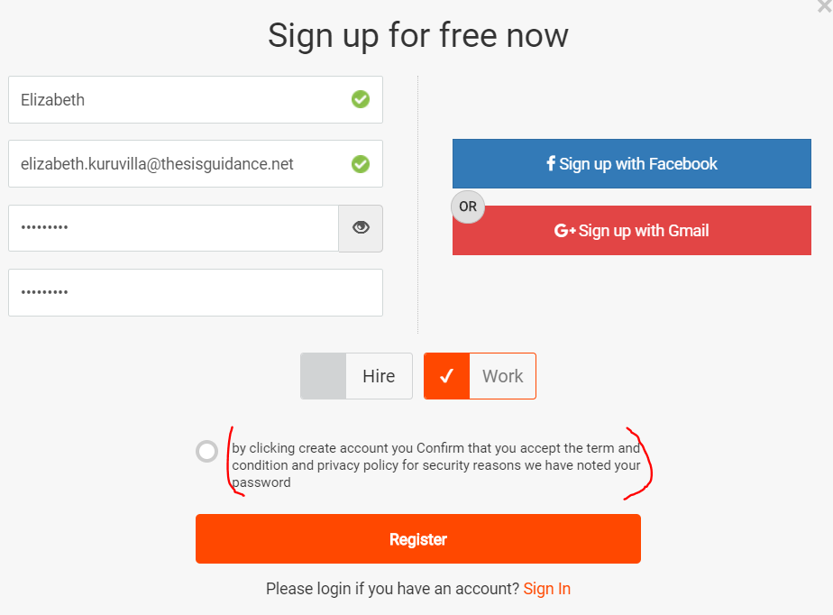

**Want work –**

* Also a link is enabled on this photo icon, which is not directed to any other page.

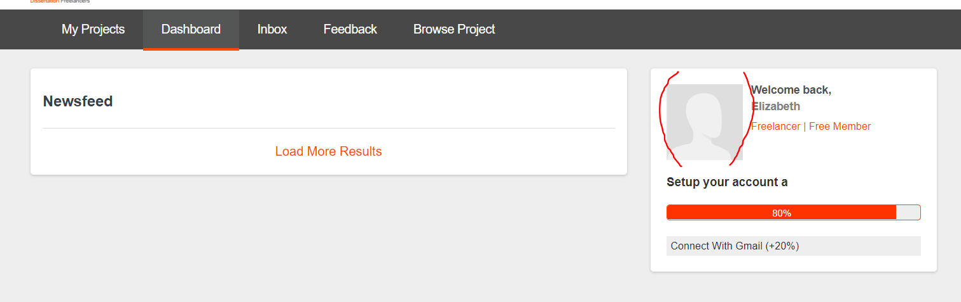

* When looking for jobs matching my skill, in ‘Skills’ field, only few options are available in the dropdown. The remaining skills can only be selected if ‘Edit Skills’ button on the top right is clicked. This functionality is not very clear, like where to update your skills.

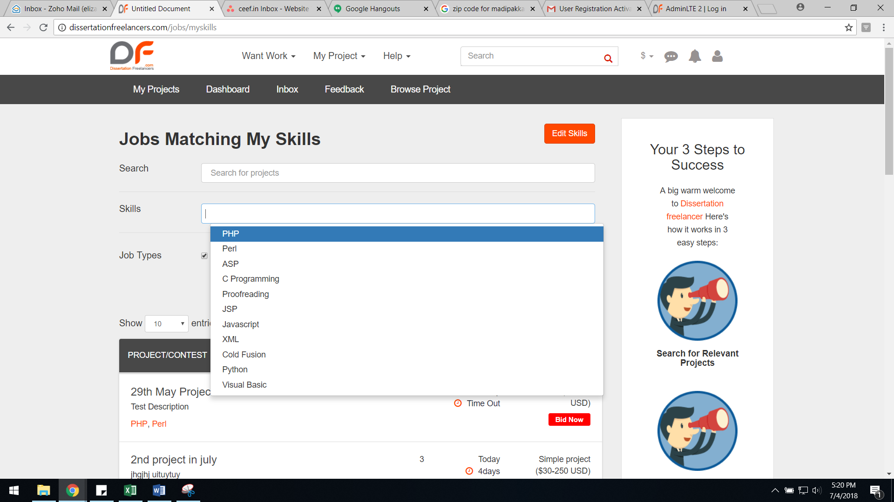

* When I search for the skill ‘Proofreading’, even those projects which do not have Proofreading are being listed.

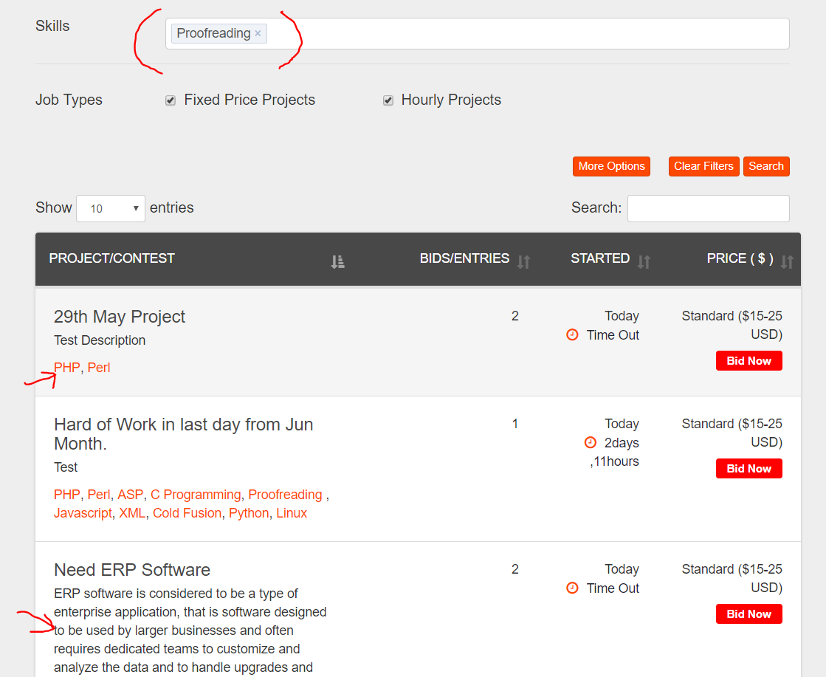

* In ‘Edit Skills’ window, the message shows 4 Jobs matching your skills, but only 3 jobs are getting listed, that too are not matching.

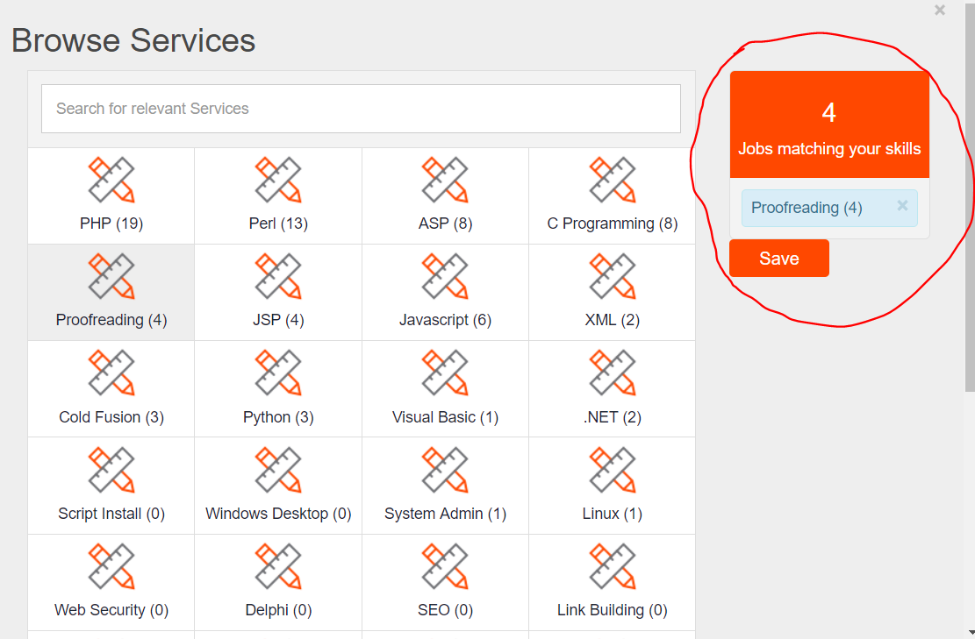

* After a bid is placed, while checking on the Dashboard, the message on dashboard is shown in two different colors. Also there is some grammar error in the sentence ‘ This bid $ 392.00 USD to complete in 9 days’. Also, use of both $ symbol and USD is not required in the same sentence.

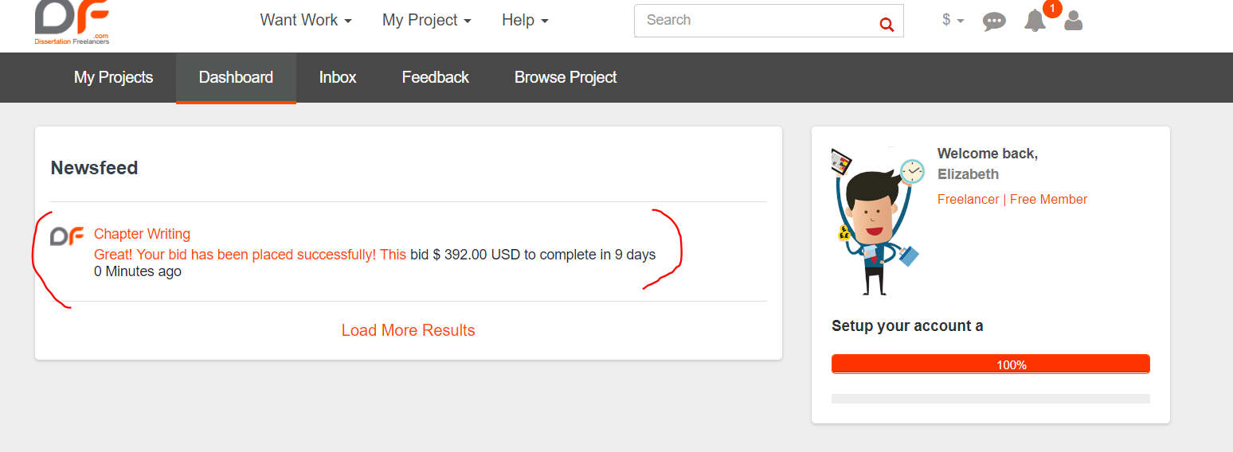

* It is difficult to find out how to send message to a client once a bid has been placed on their project.

My Project >> In Action, select the Send Message in dropdown

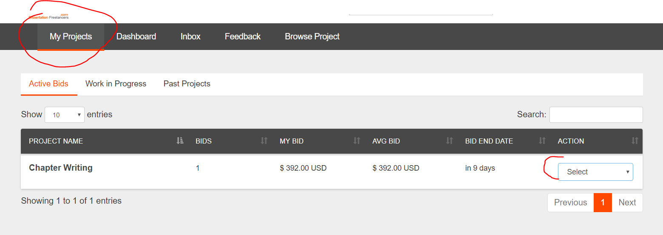

* In Inbox, when a message is typed, on pressing ‘Enter’ key, the message disappears from the message box, however, it doesn’t get posted. Only when you re-type the message and press ‘SEND’ button is getting posted.
* The link for attachment is enabled in the entire box. It should be only on the icon

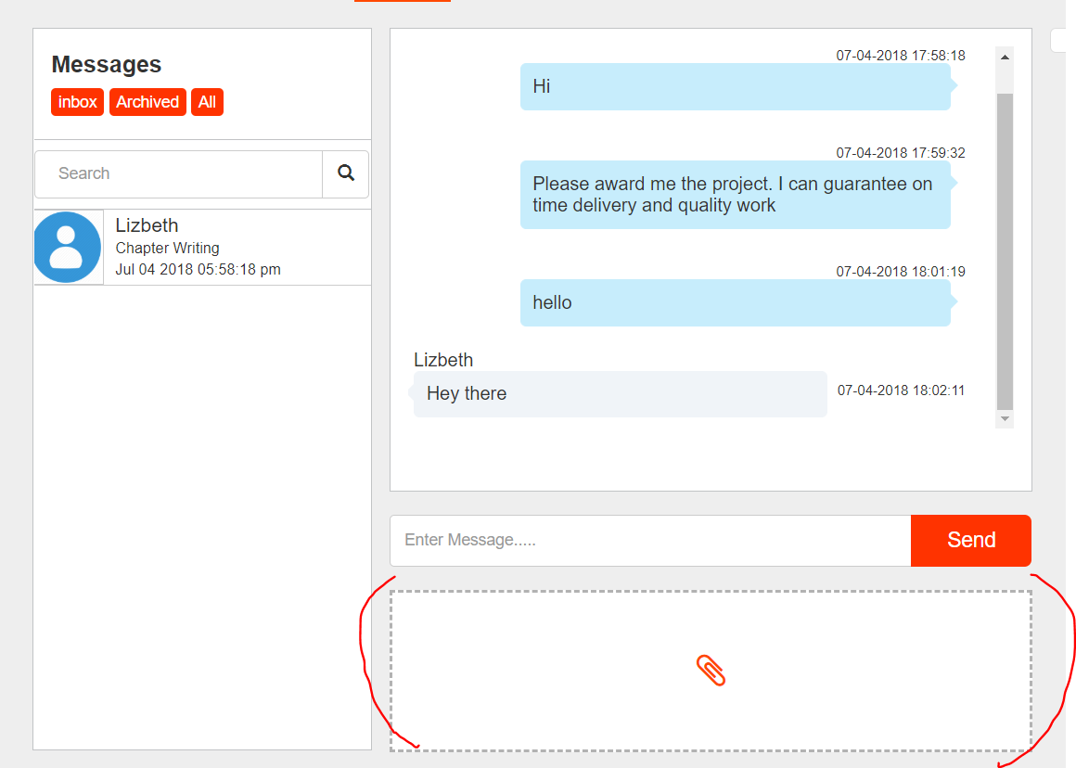

* After a file has been attached, there is no option to send it. Clicking on ‘SEND’ doesn’t work. Not sure how to send it into the Inbox.

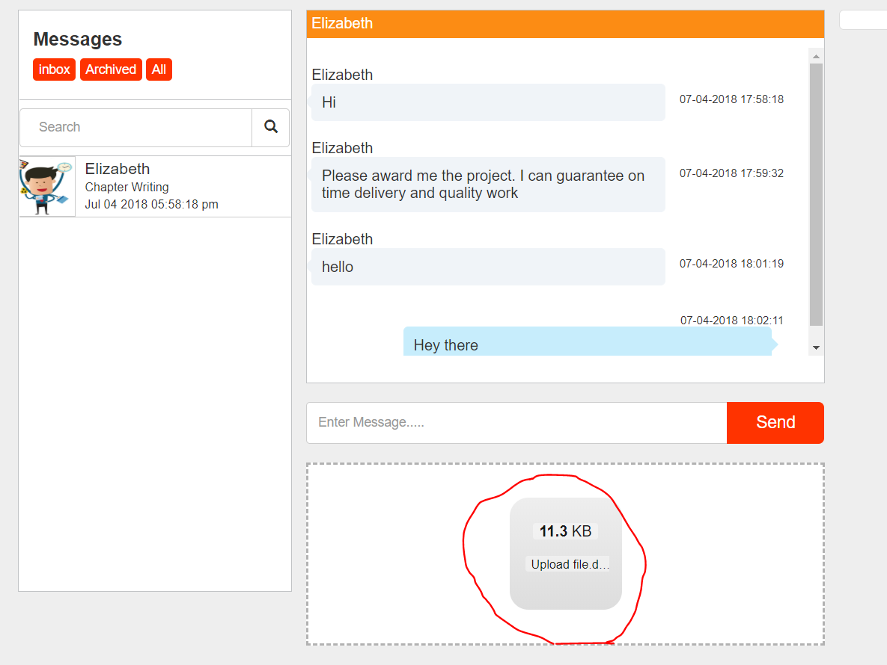

* The bid was changed from $392 to $364 by the freelancer. It is showing $364 in ‘My Projects’, but on Dashboard, it is still showing the old bid $392. Same on the ‘Hire Freelancer’ account as well.

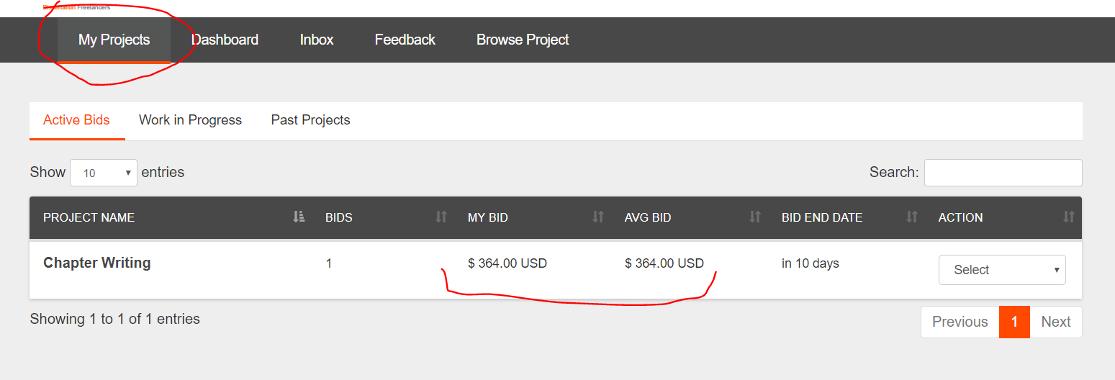

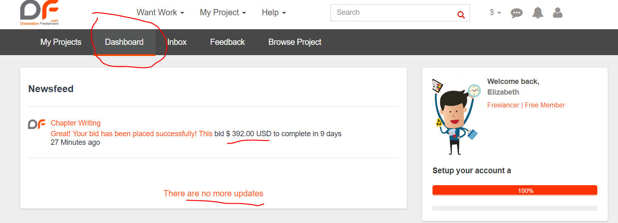

* My Projects >> Work in Progress >> View >> Milestone Details – link is enabled in the box, which is not getting directed anywhere

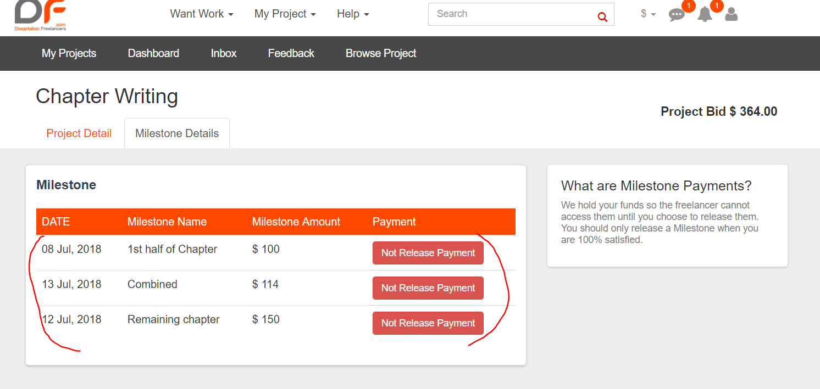

**Hire Freelancer –**

* On ‘Start Project’, in the field ‘What skills are required’, all the list of skills active in the Admin panel are not getting listed in the dropdown. Even if I try to type those skills, it’s not being accepted.

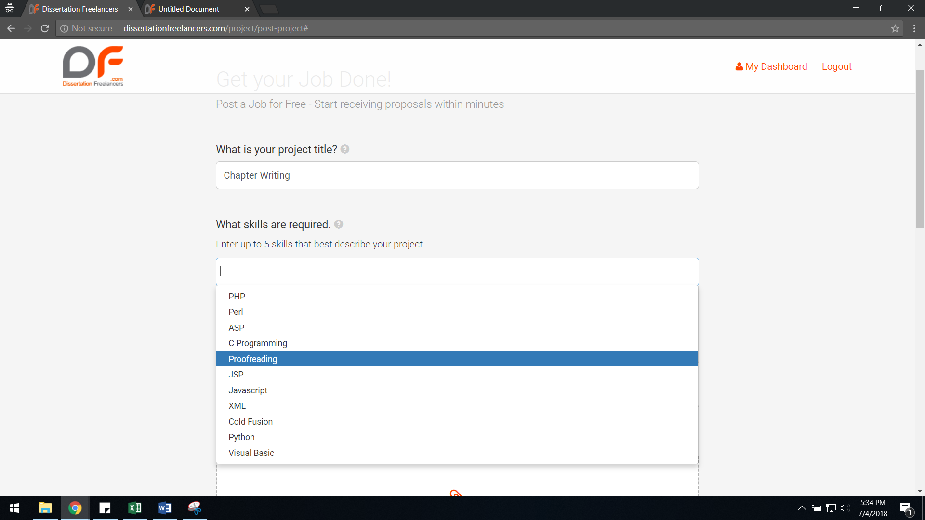

Not accepting the skill ‘editor’ which is active in Admin panel –

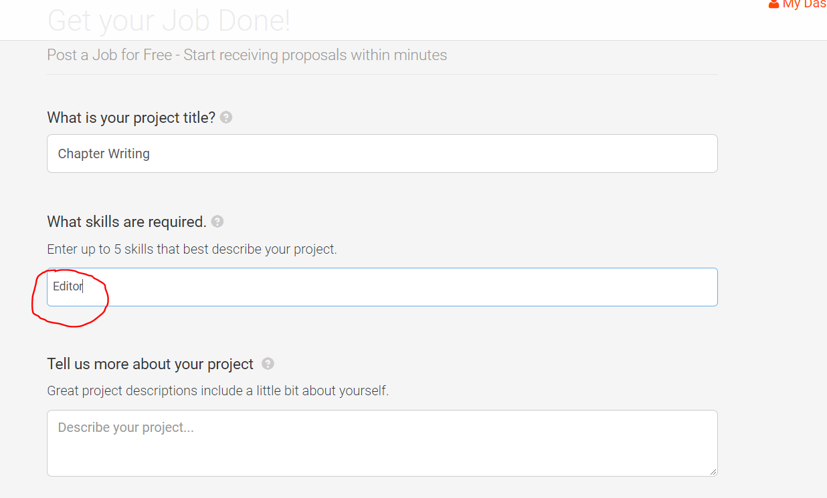

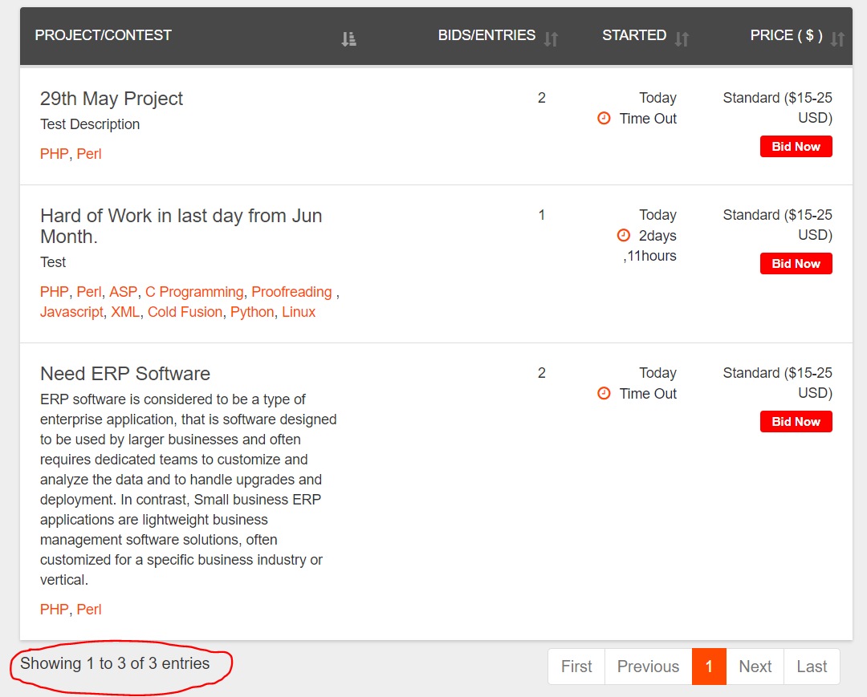

* If I am clicking on ‘Post Project’, if there is an error in any of the fields in the form, it is only visible if the user scrolls up and checks.
* When the Project was awarded to the freelancer and the milestones were created, while the page was directed to the payment gateway, ‘Connection not private’ page was obtained. ON giving ‘Back to safety’ option, the milestones have been created. But, there is no option to process the payment thereafter in the account.  
    
  Dashboard >> View Project – Status is pending. (No option for payment after this).

