**All web site**

**Page Speed:**

Mobile: 66

Desktop: 68

**W3 validator error:**

**Error**: 3

**Warning**:3

<http://360emarketz.com/gunjan/plagirism/index.php>

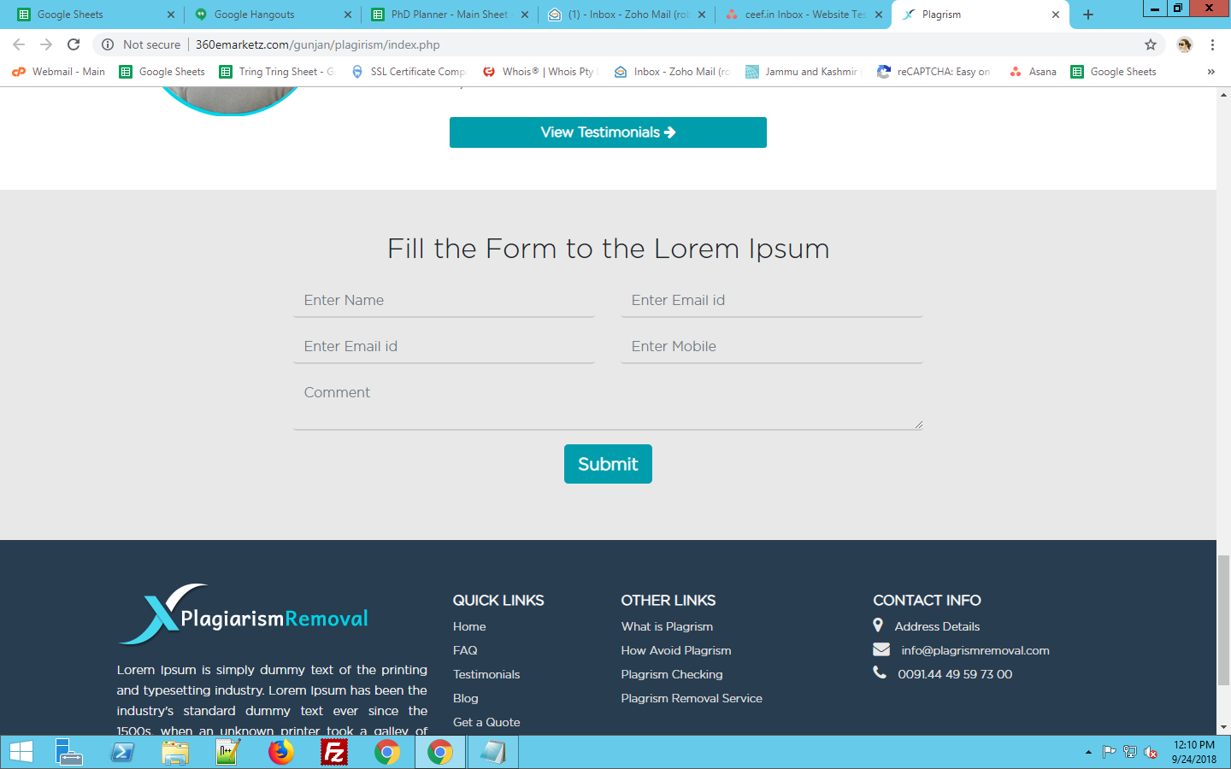

Email id two time used

Button not Right side

form not working

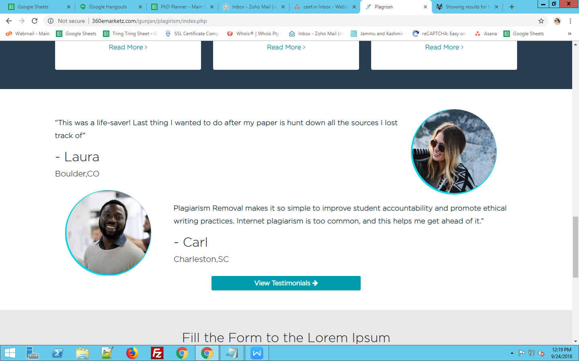

Button Size long and image long

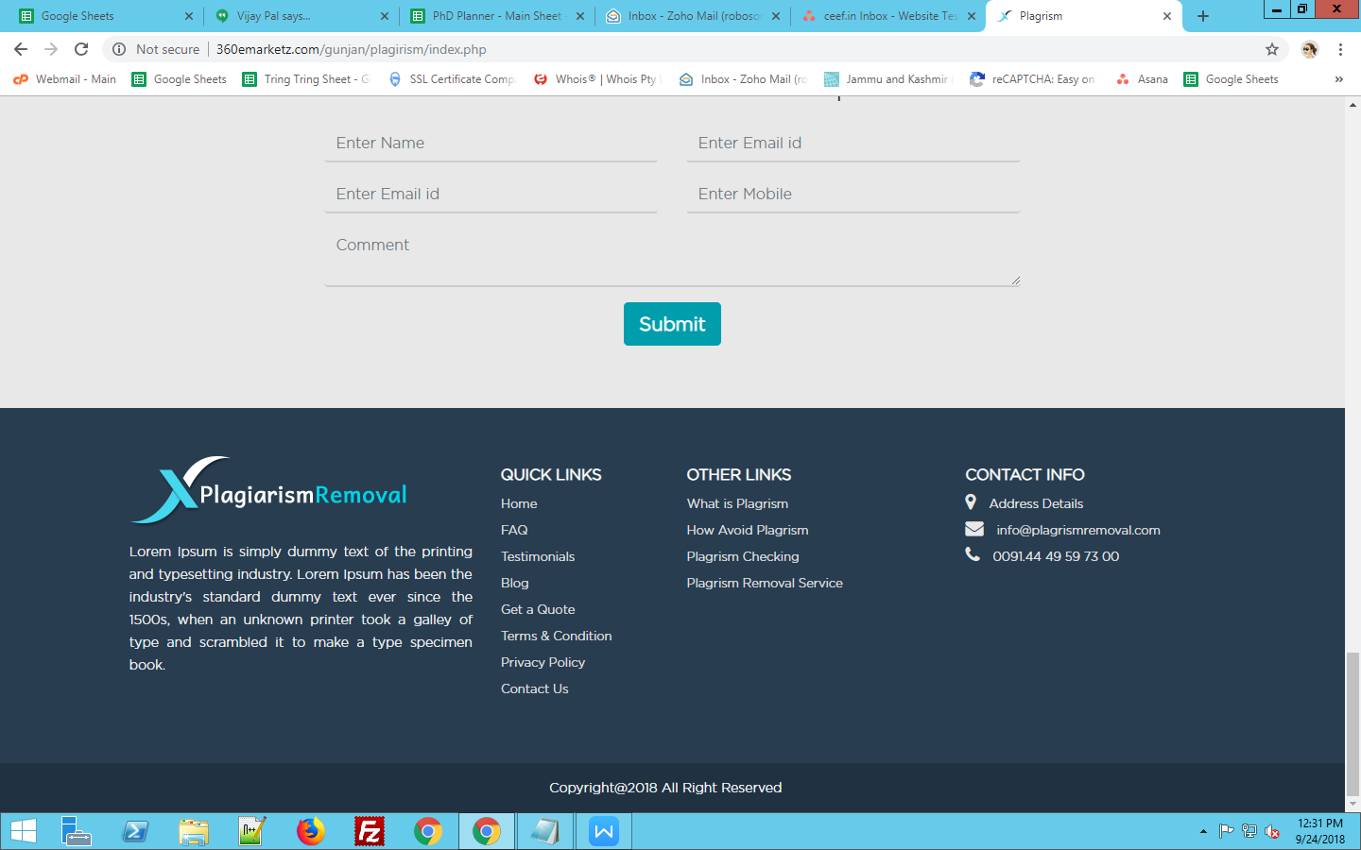

Address not provide

Email id and phone number not correct

Right: Rights

All button not hover

<http://360emarketz.com/gunjan/plagirism/what-is-plagrism.php>

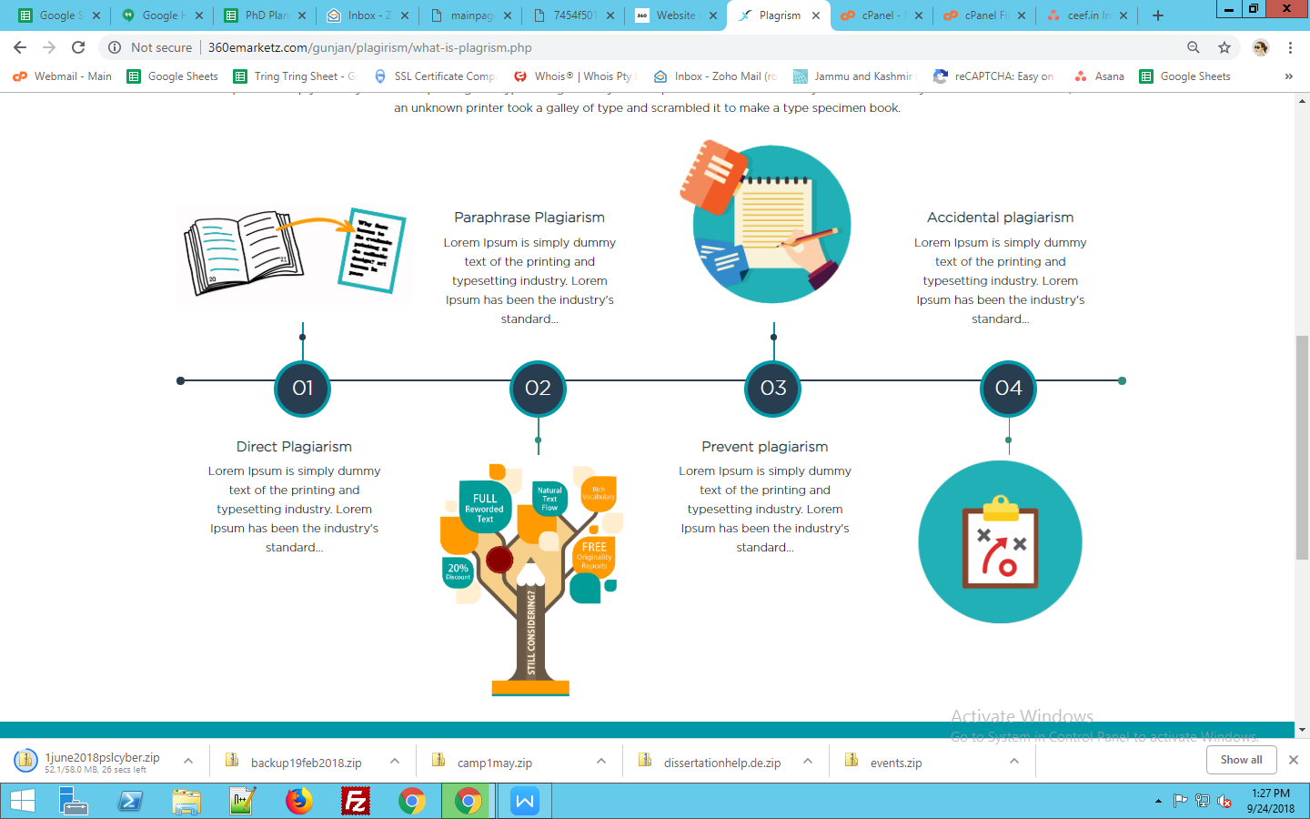

### [second letter not Capital](https://www.skillsyouneed.com/write/capital-letters.html)

### 

### [Check:First letter not capital](https://www.skillsyouneed.com/write/capital-letters.html)

Mobile view:

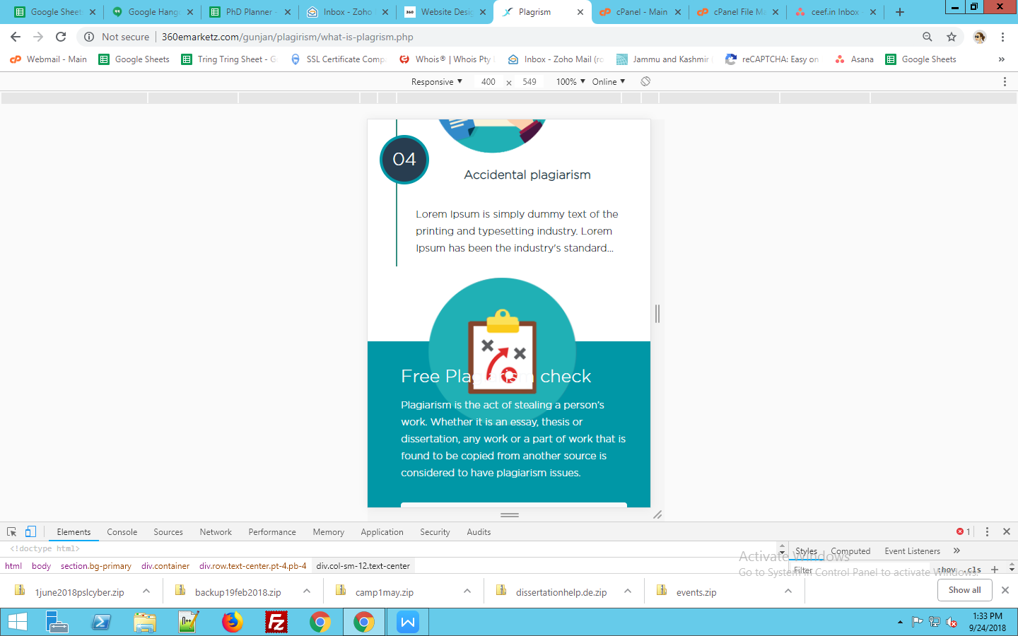

Img overlap

Mobile view

<http://360emarketz.com/gunjan/plagirism/plagrism-removal.php>

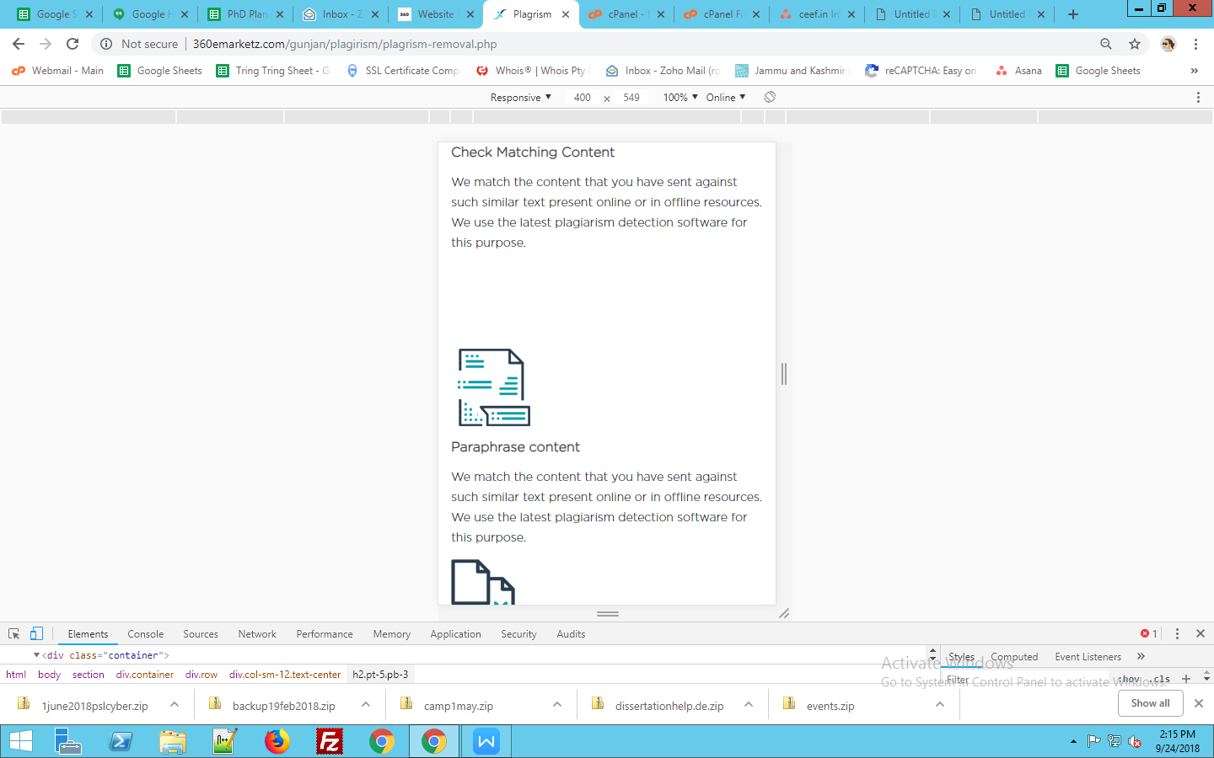

<http://360emarketz.com/gunjan/plagirism/contact.php>

Mobile View

|  |
| --- |
|  |

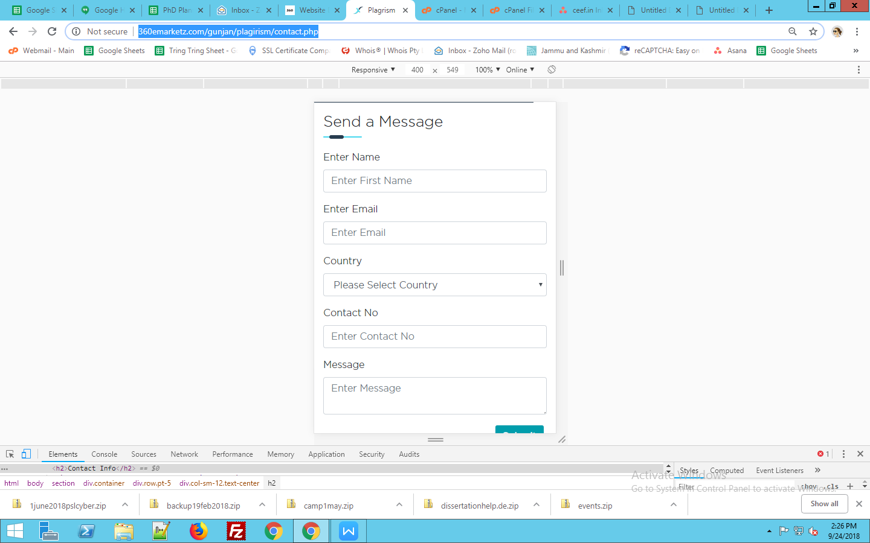

Enter first name

form not working

<http://360emarketz.com/gunjan/plagirism/privacy-policy.php>

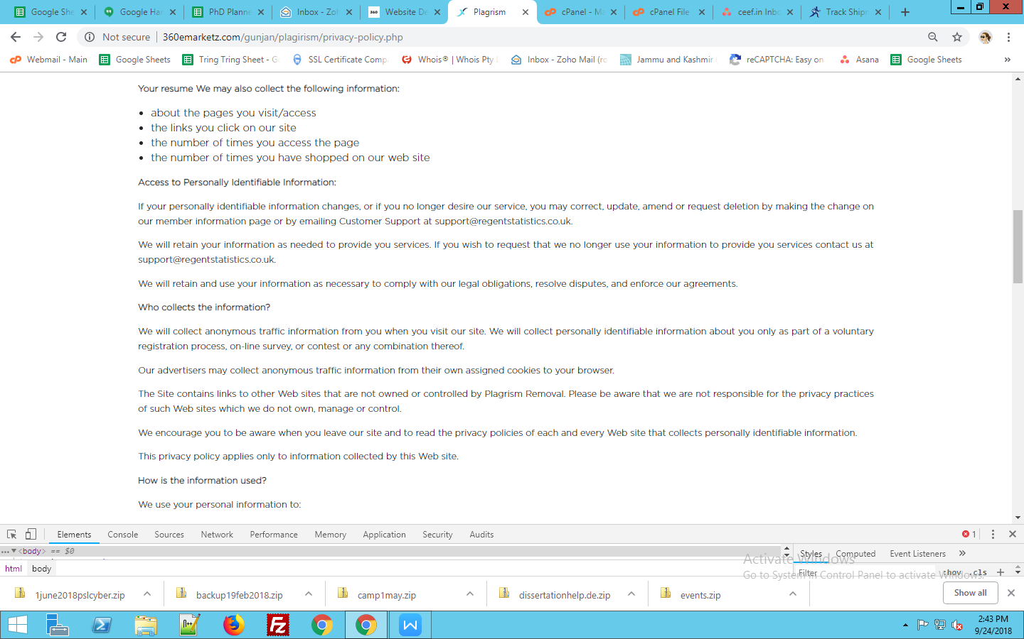

Support email id not this [website”support@regentstatistics.co.uk.”](mailto:website\”support@regentstatistics.co.uk.\”)

<http://360emarketz.com/gunjan/plagirism/get-quote.php>

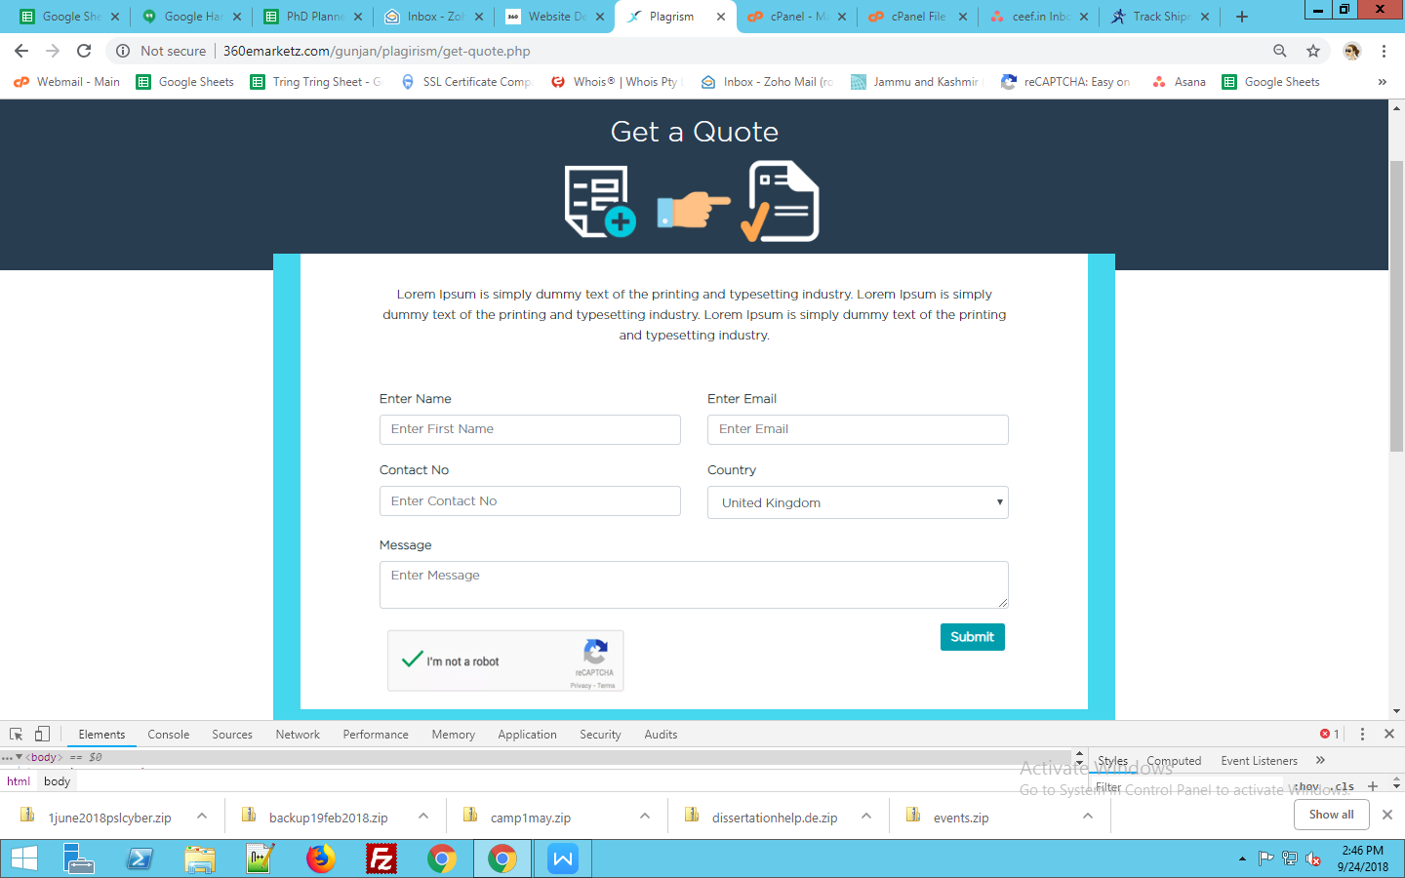

Enter first name not required

Contact no. not used before country name

form not working