<https://www.360website.net/>

**Page speed:**

Mobile/Desktop: 79



Photo

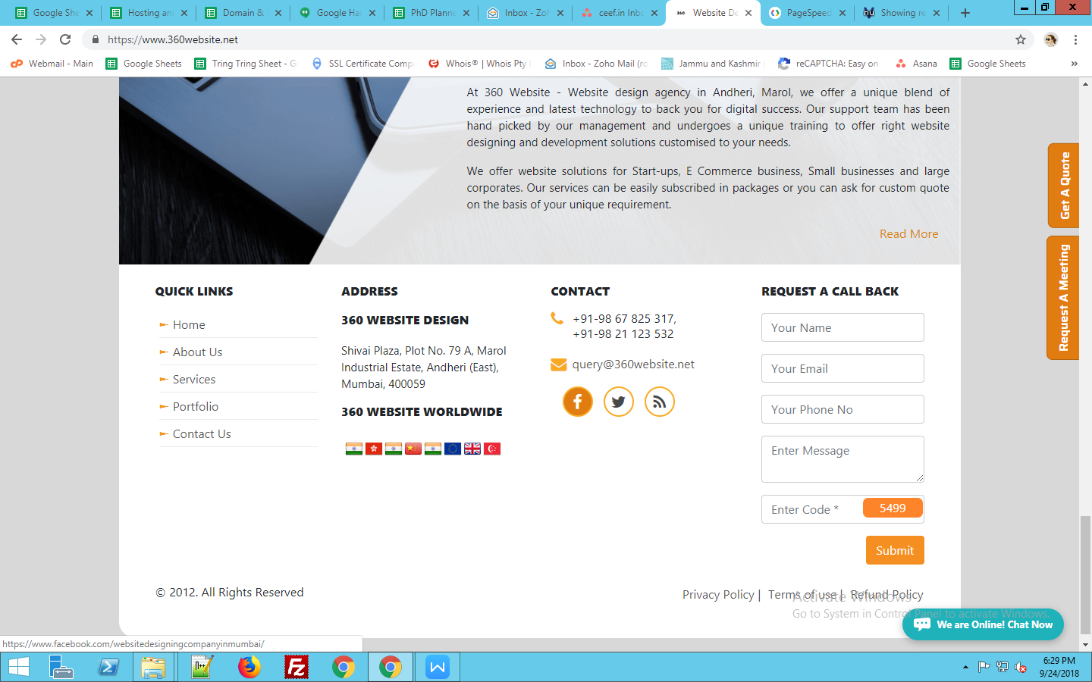

Phone number: +91-98 67 825 317,

<https://www.360website.net/privacy-policy.php>

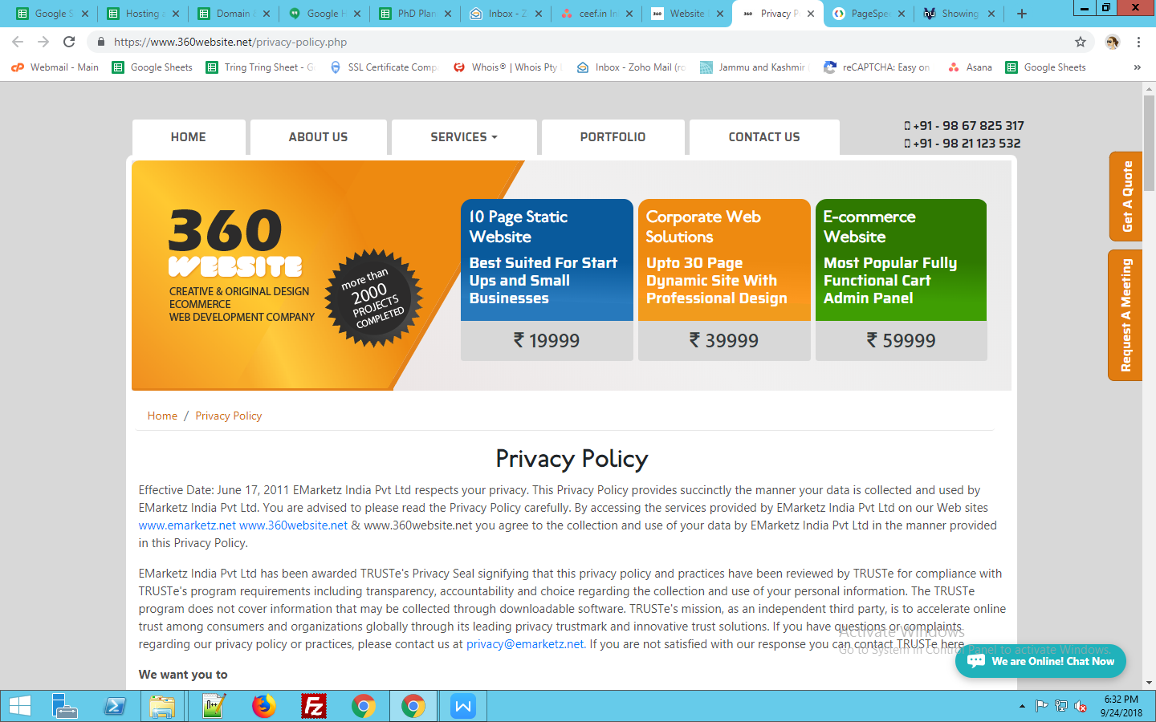

Website Url used in 2time

<https://www.360website.net/contact-us.php>

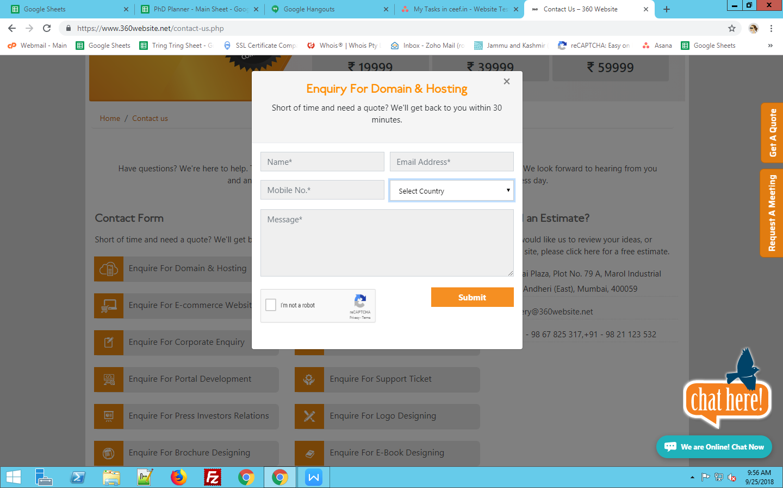

Phone number used before Country name

<https://www.360website.net/web-development-company.php>

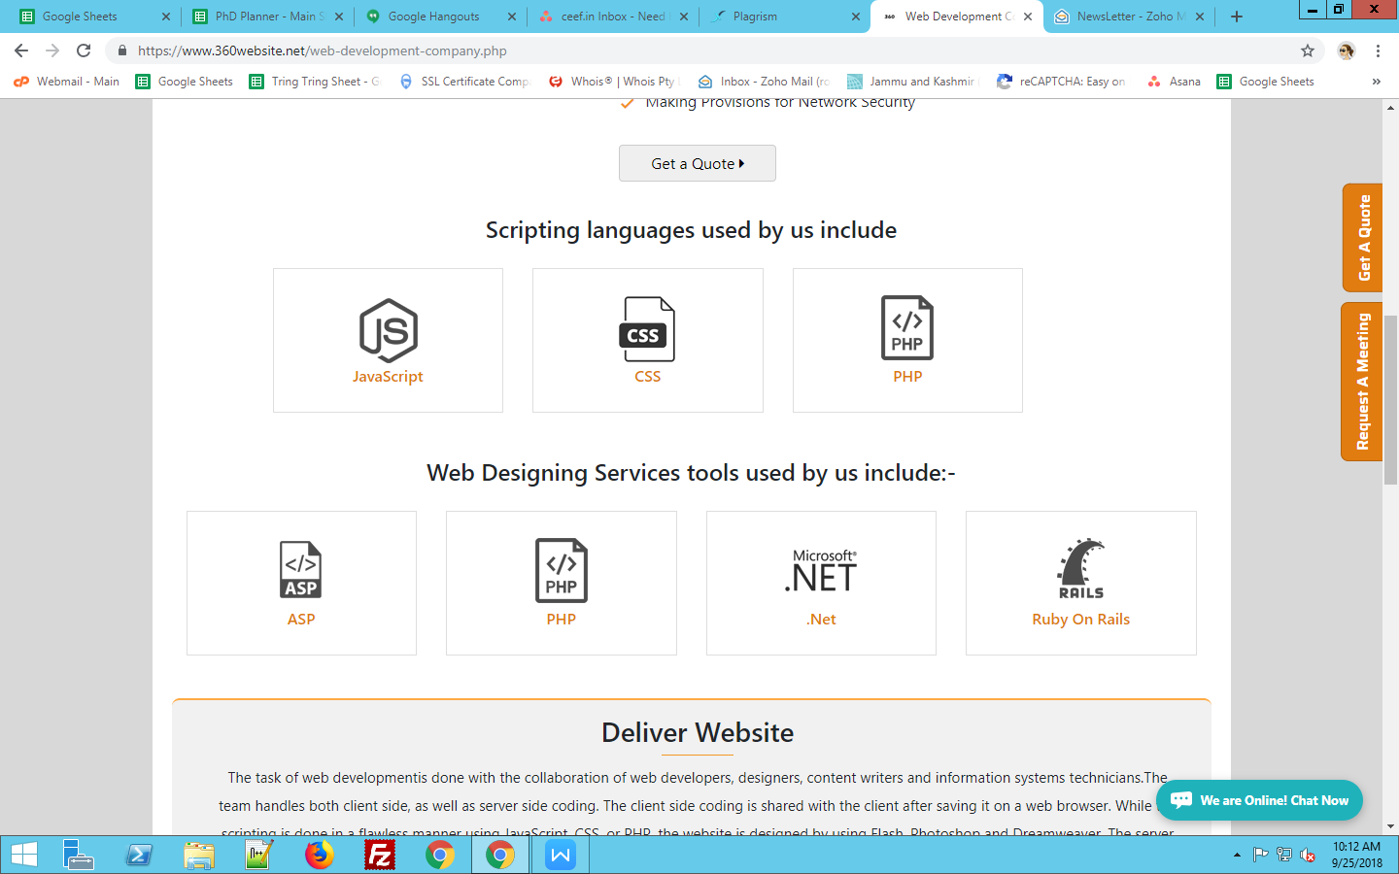

two time used

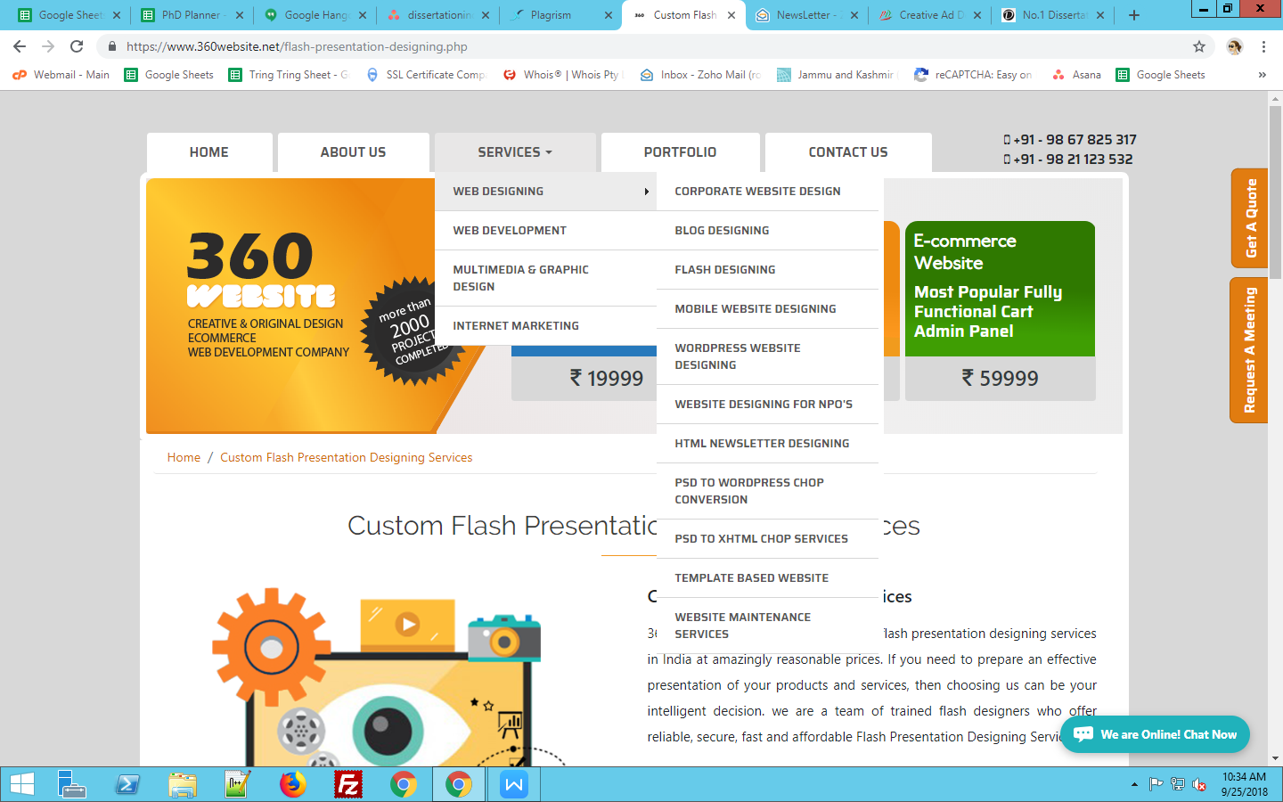

<https://www.360website.net/10-page-static-website.php>

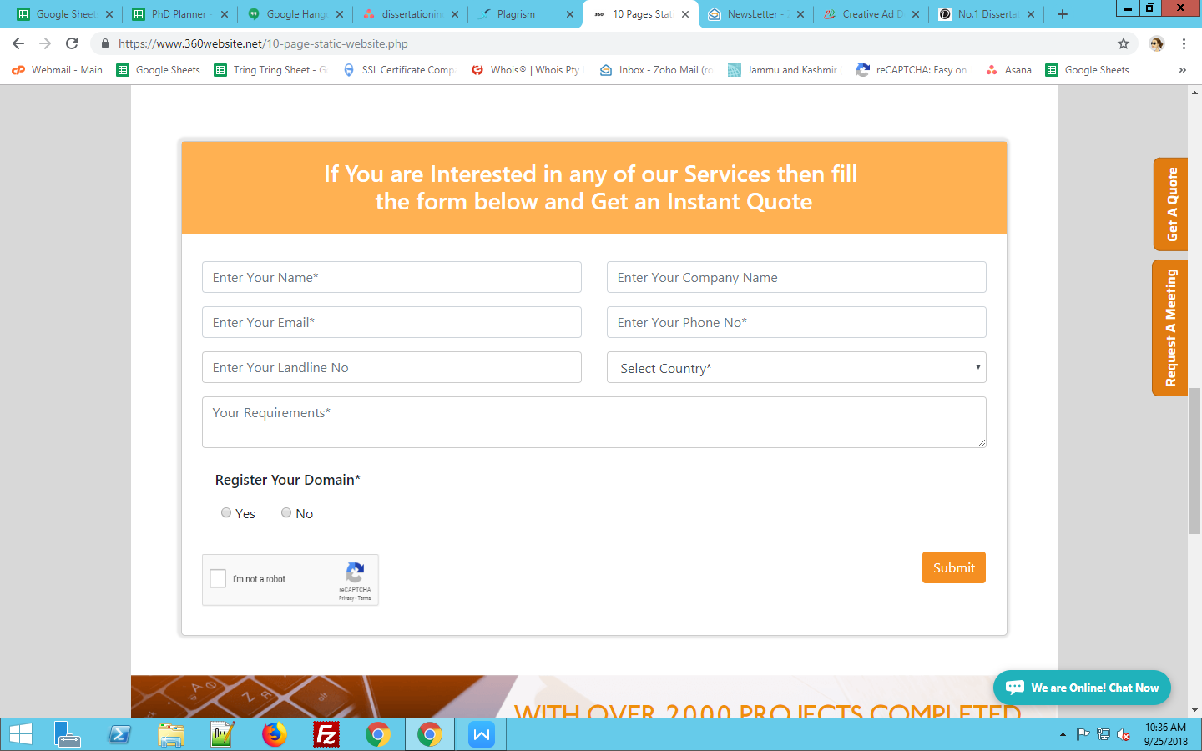

Phone number used before Country name

<https://www.360website.net/e-commerce-website.php>

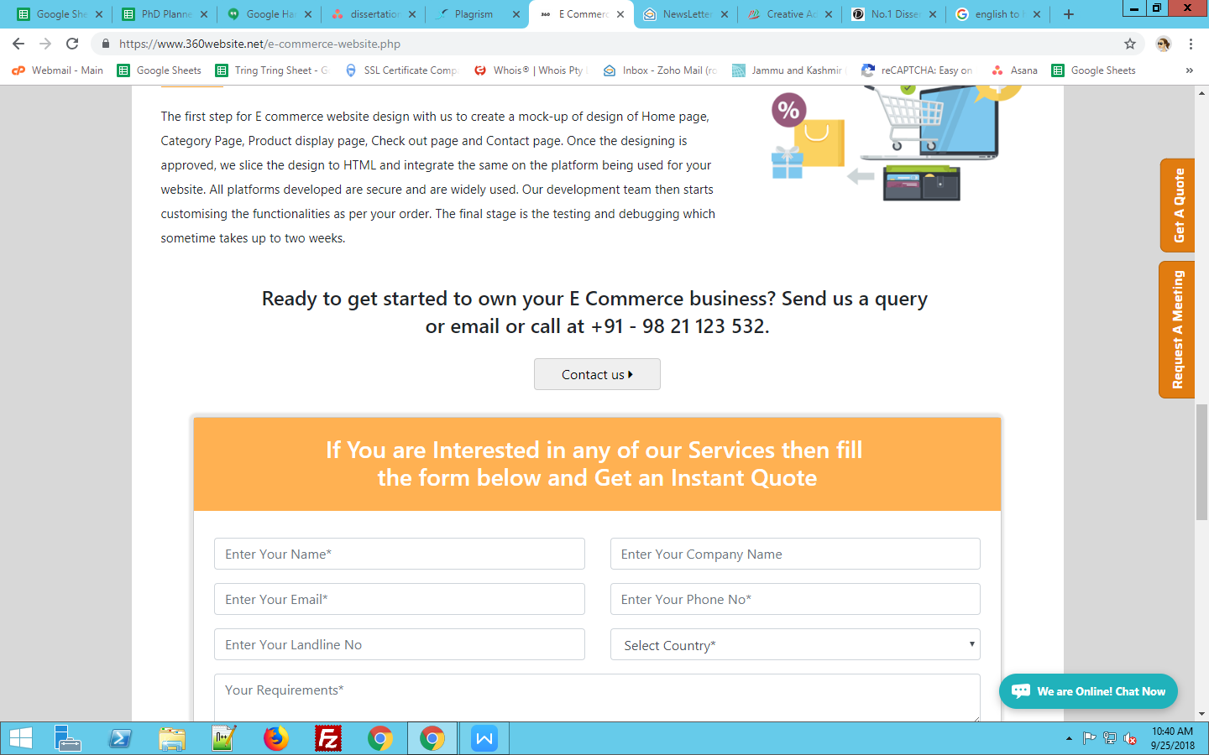

Email id not provide

And phone number used before country name