**Designer Issues:**

1. When clicked on signup button without filling any fields then there should **show tooltip** to fill them. It should show all the fields with mandatory symbol and there should be confirm password another text field.

<http://5feedoutsourcing.com/>

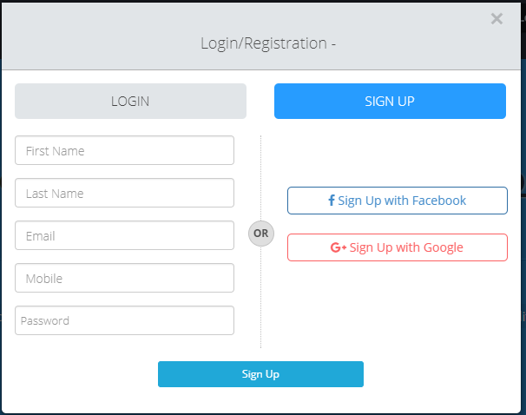

1. The form has more gap , when displaying the error message below.

<http://5feedoutsourcing.com/contact-us.php>

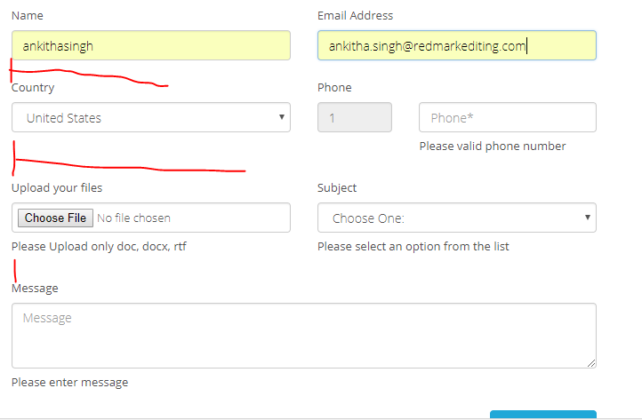

1. In footer, “Academic content writing” section should be placed above the “About”. Design the footer properly

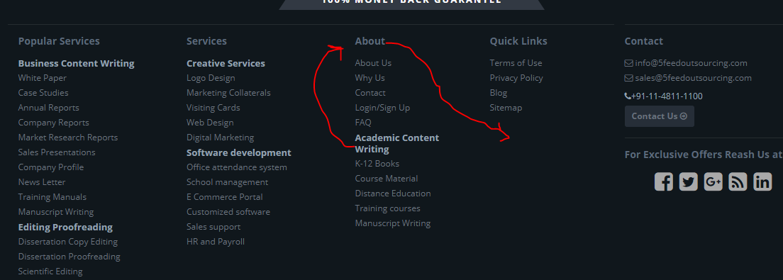

1. In footer, the Academic content writing is written with more space.

<http://5feedoutsourcing.com/privacy-policy.php>

1. In “Academic content writing” and “Academic editing” form there is 3 text fields missing. Add the same as in the other forms.

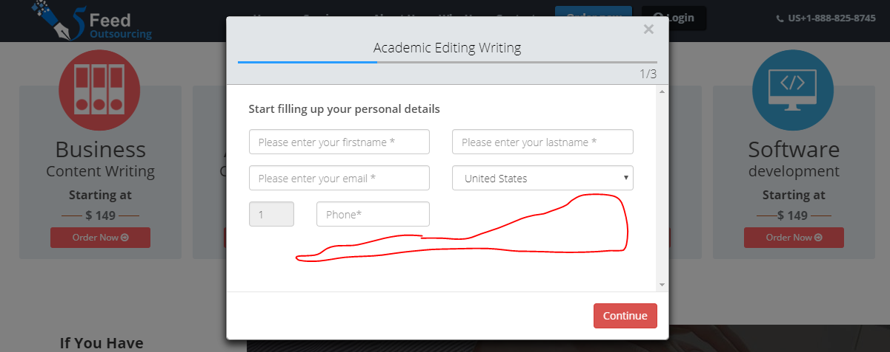

1. Icons are not present the icons

<http://5feedoutsourcing.com/training-manuals.php>

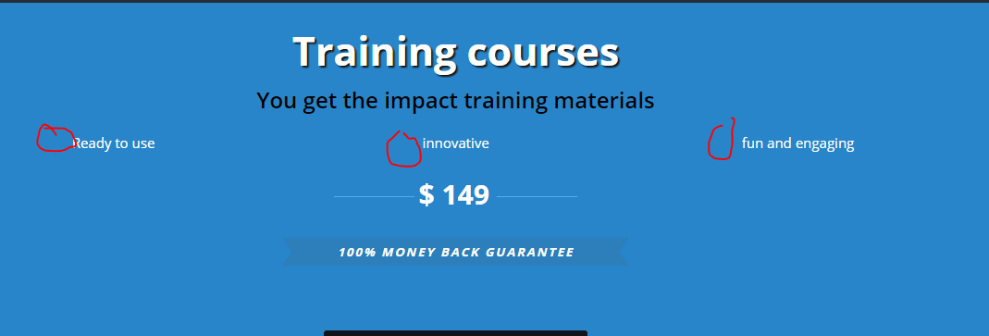

1. “Order now” button is wrong. Place as same design as in other pages

<http://5feedoutsourcing.com/logo-design.php>

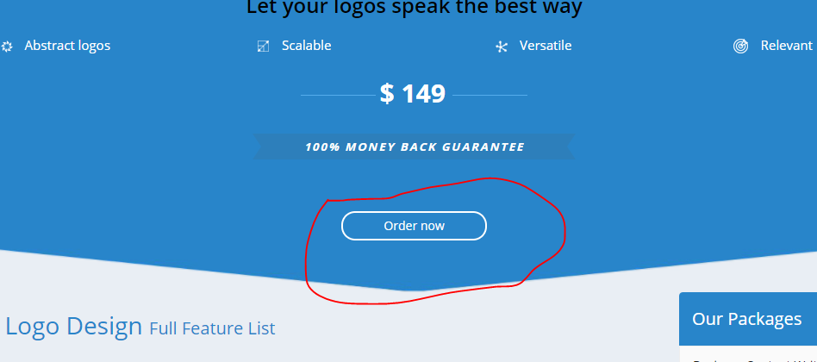

1. Blog page is empty

<http://5feedoutsourcing.com/blog.php>

1. “Academic content writing” section is missing in the Sitemap

<http://5feedoutsourcing.com/sitemap.php>

1. 15 - w3c error
2. 72 – mobile speed

**Developer issue:**

1. Unable to Login or Signup. Not even with facebook and google+. Also forgot password is not working, work on all this.
2. The mandatory details if not filled then the error message should be displayed in same page rather than in next page.

<http://5feedoutsourcing.com/order_now.php>

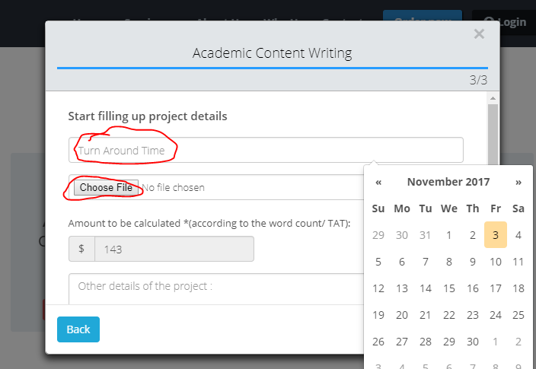

1. The confirmation mail and main mail has “document file” presented in wrong way. The main mail should address as “Dear admin”.

<http://5feedoutsourcing.com/order_now.php> (all 5 forms)

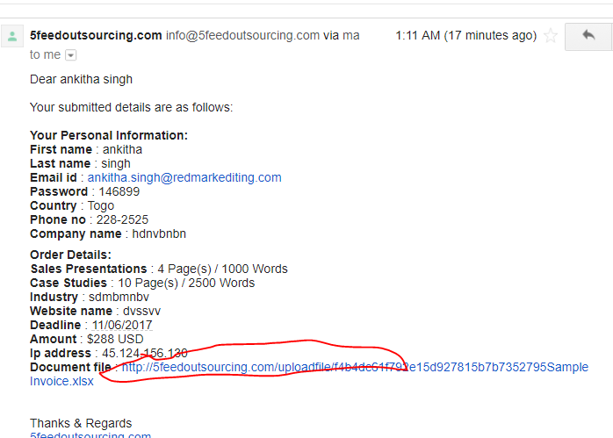

1. There are no breadcrumbs in any pages. Check all the pages

<http://5feedoutsourcing.com/about-us.php>

1. No captcha for this form

<http://5feedoutsourcing.com/contact-us.php>

1. Main mail received for contact us form has issues.

<http://5feedoutsourcing.com/contact-us.php>

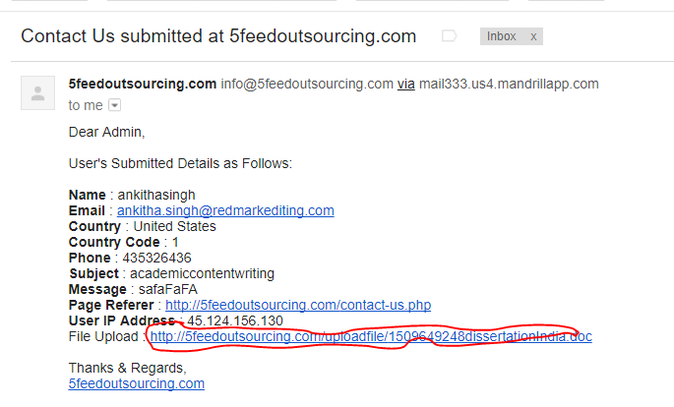

1. Forgot password is not working

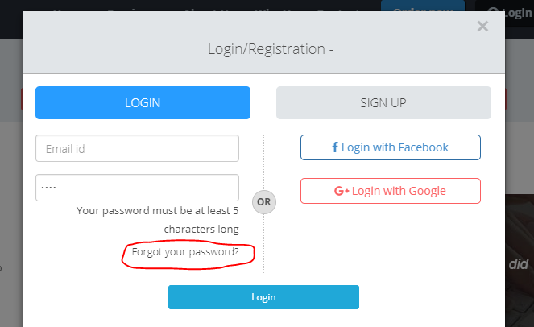

1. There is no captcha in all the 5 forms

<http://5feedoutsourcing.com/>

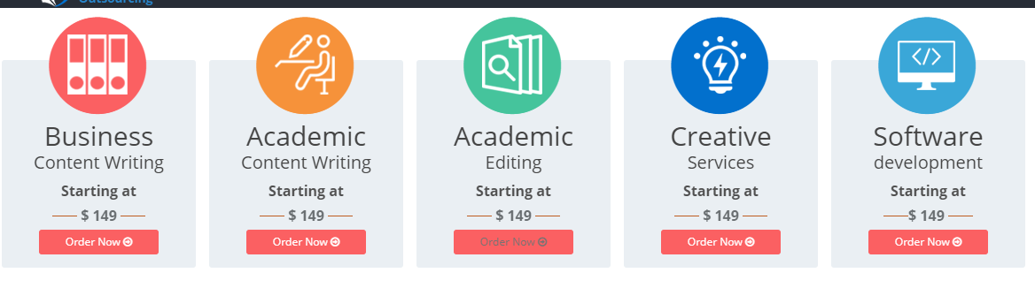

1. Also need to add the chat box