DESIGN ISSUES (Niranjan Sir / Happy)

1) There should be heading as "Ask for Quote" and for service text field there is double "*" symbol, remove one.
http://www.editingproofreading.com.my/ask-for-quote
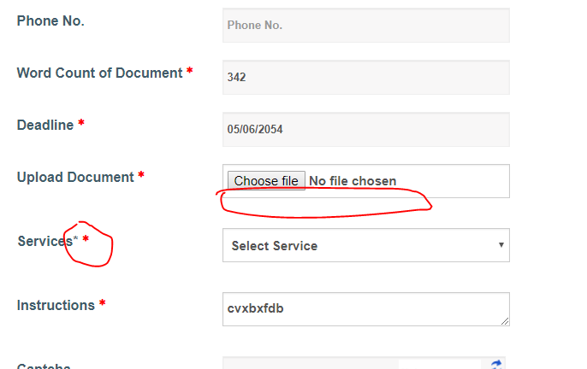
2) There is no link
http://www.editingproofreading.com.my/contact-us

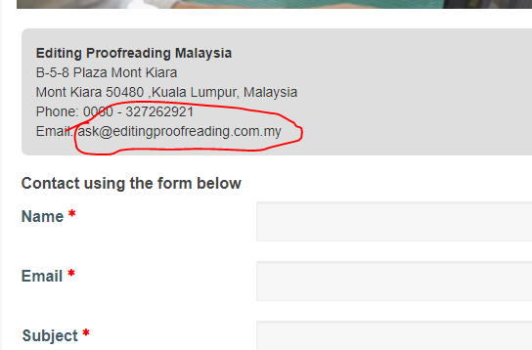

3) Phone number text fields is accepting alphabets
http://www.editingproofreading.com.my/place-order

4) Replace "Subject" text field to contact number
http://www.editingproofreading.com.my/contact-us

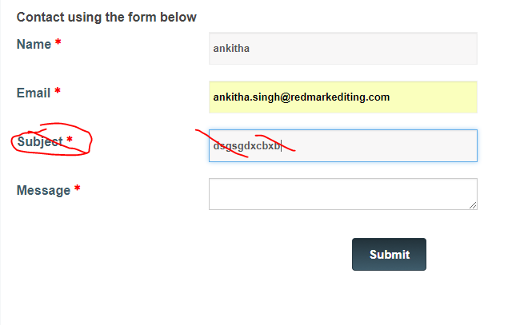

- The tooltip design for Ask for quote, Place order, contact us is not good. Re-design it
http://www.editingproofreading.com.my/contact-us
http://www.editingproofreading.com.my/place-order
http://www.editingproofreading.com.my/ask-for-quote

7) Blog should appear like
http://www.chanakyatutors.com/blog/

================================================================

RAVI - DESIGN ISSUES

1) By default it should be " Please select"
http://www.editingproofreading.com.my/place-order

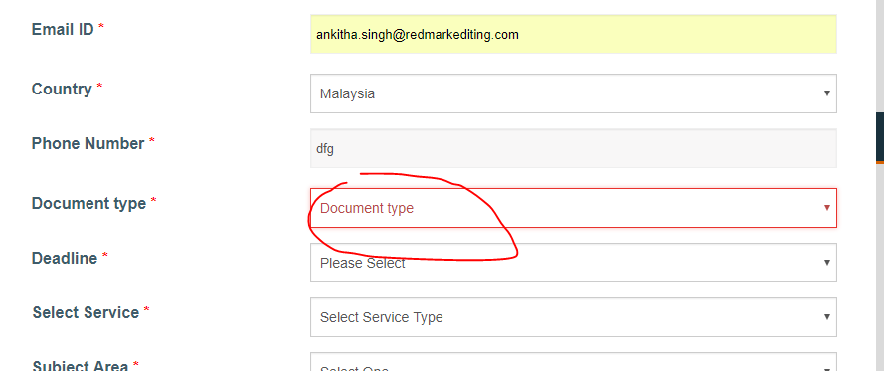

2) Place this content below the checkbox.
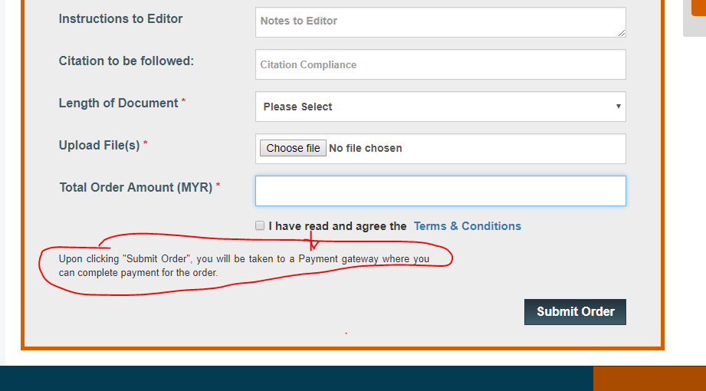
http://www.editingproofreading.com.my/place-order

3) Remove the text inside the text field
http://www.editingproofreading.com.my/ask-for-quote

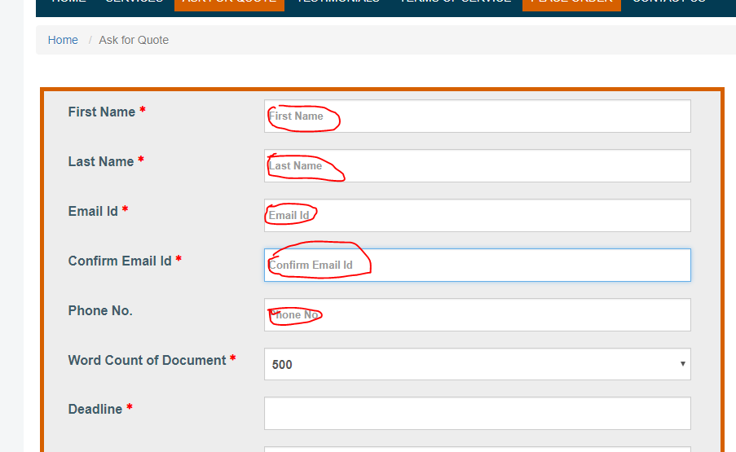

4) Remove the text inside the text field
http://www.editingproofreading.com.my/place-order
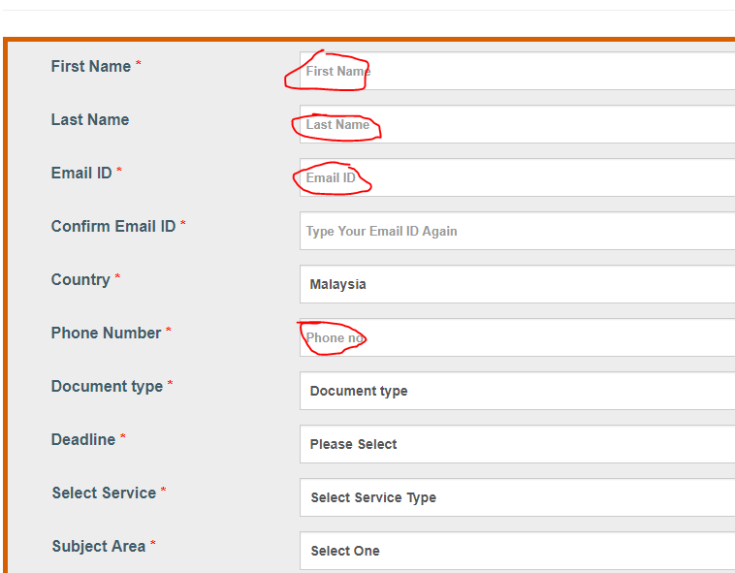

5) Responsive issue
http://www.editingproofreading.com.my/place-order
http://www.editingproofreading.com.my/blog/17-proofreading

6) W3C error is 22.

7) In all the inner pages, adjust the banner like this
http://doctorateinuk.com/contact-us/

And place the contents on that

http://www.editingproofreading.com.my/services/dissertation-editing-service-malaysia
- Editing
http://www.editingproofreading.com.my/services/dissertation-proofreading-service-in-malaysia – Proofreading
http://www.editingproofreading.com.my/ask-for-quote – Ask For Quote Form
http://www.editingproofreading.com.my/place-order – Place Order Here
http://www.editnpublish.com/contact/ - Contact Us
http://www.editingproofreading.com.my/terms-of-service
http://www.editingproofreading.com.my/testimonials
http://www.editingproofreading.com.my/blog – Blog
http://www.editingproofreading.com.my/sitemap - Sitemap

