1. Read More button in the banner is not coming proper on the home page.

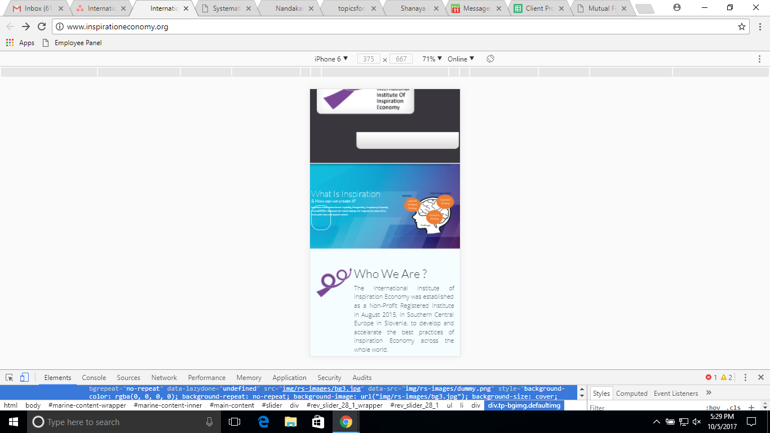

1. Spacing issues in the logos on the home page

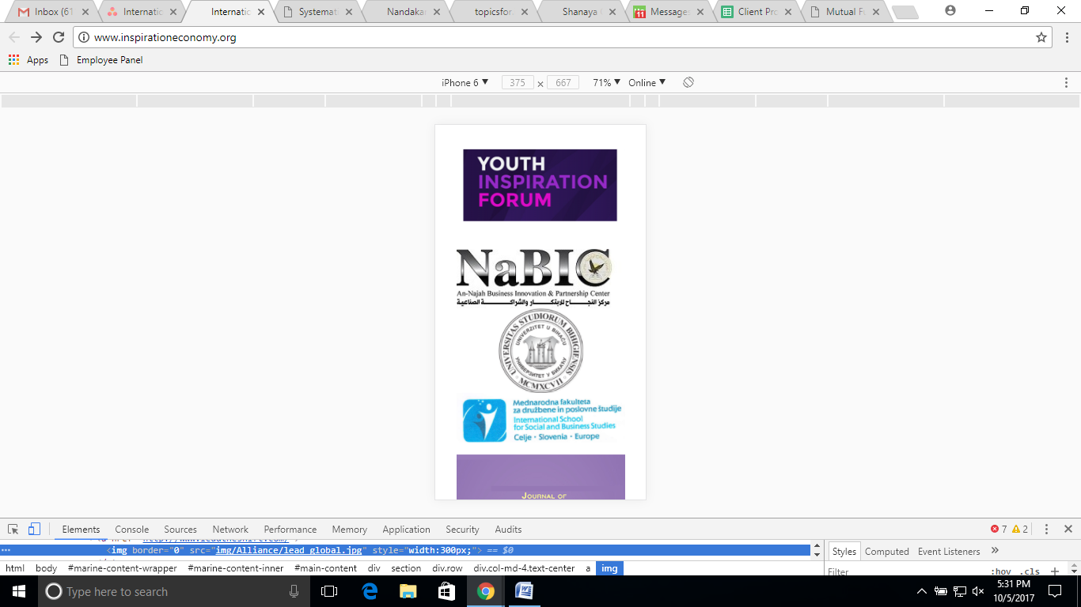

1. Menu not working properly. All the inner pages are not opening when we click on the name. They are opening only once the user clicks on + icon.
2. <http://www.inspirationeconomy.org/youth-activities>

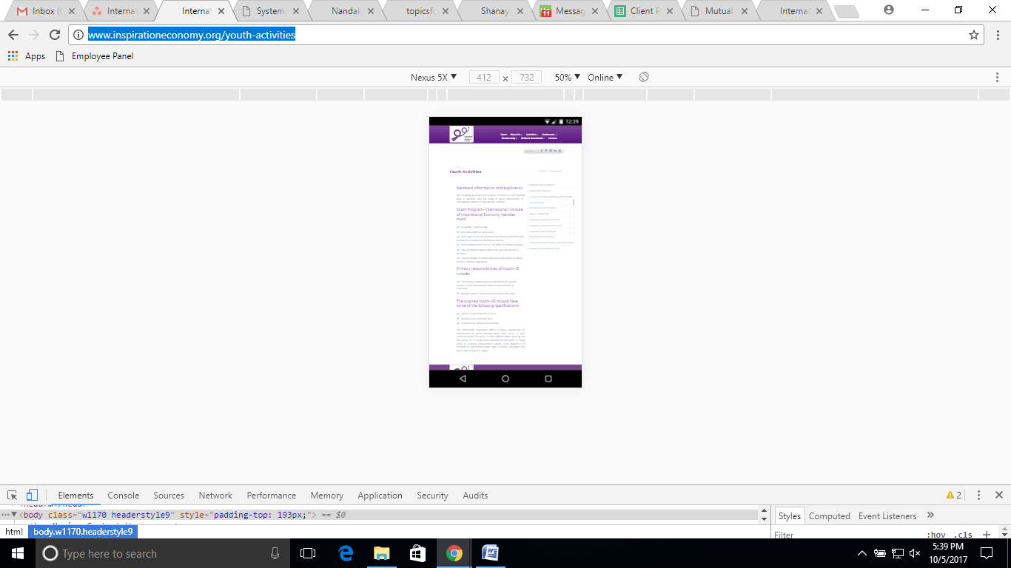

1. <http://www.inspirationeconomy.org/call-for-papers>

Form not coming proper and text not justified.

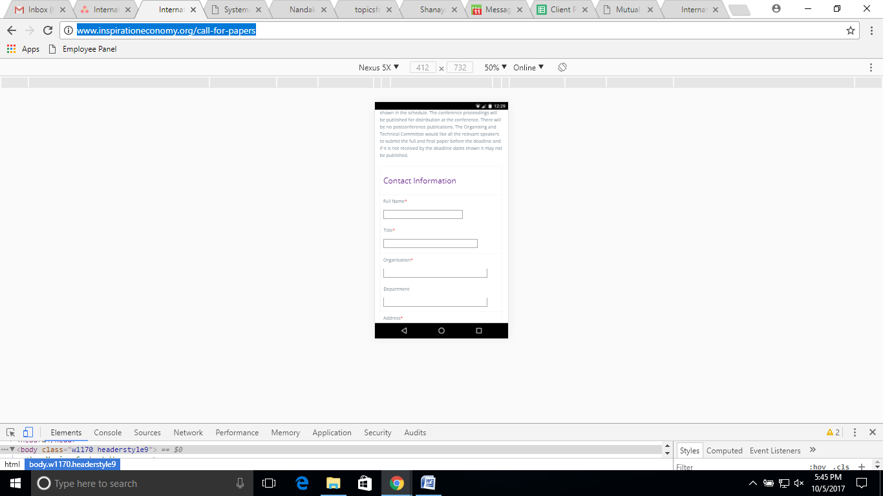

1. <http://www.inspirationeconomy.org/membership-details>

Table not coming proper.

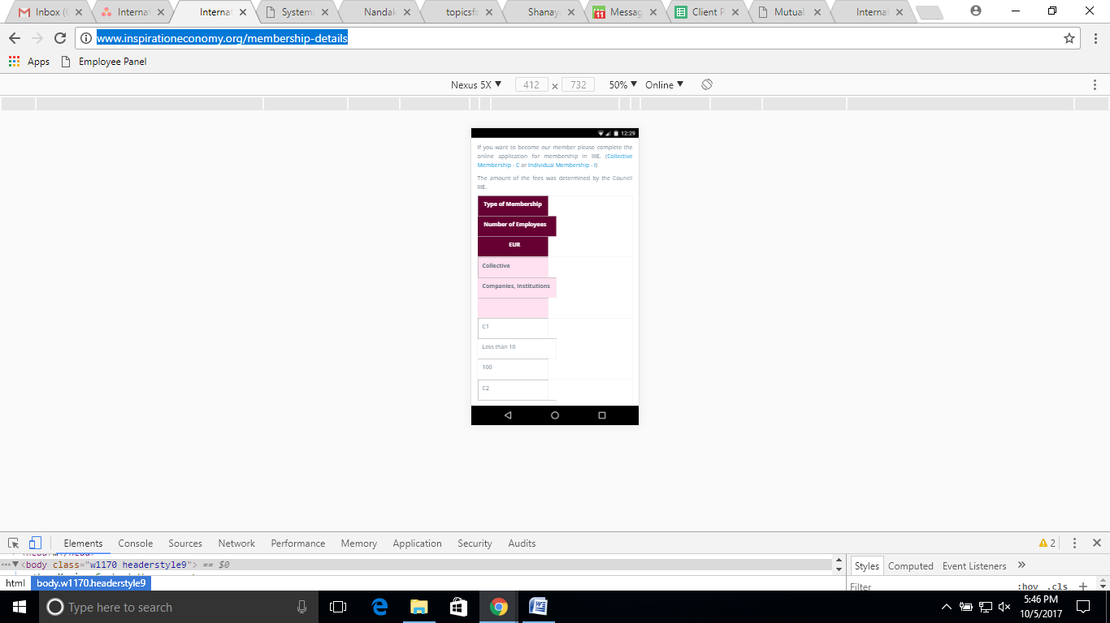

1. <http://www.inspirationeconomy.org/collective-membership>

Design not coming proper.

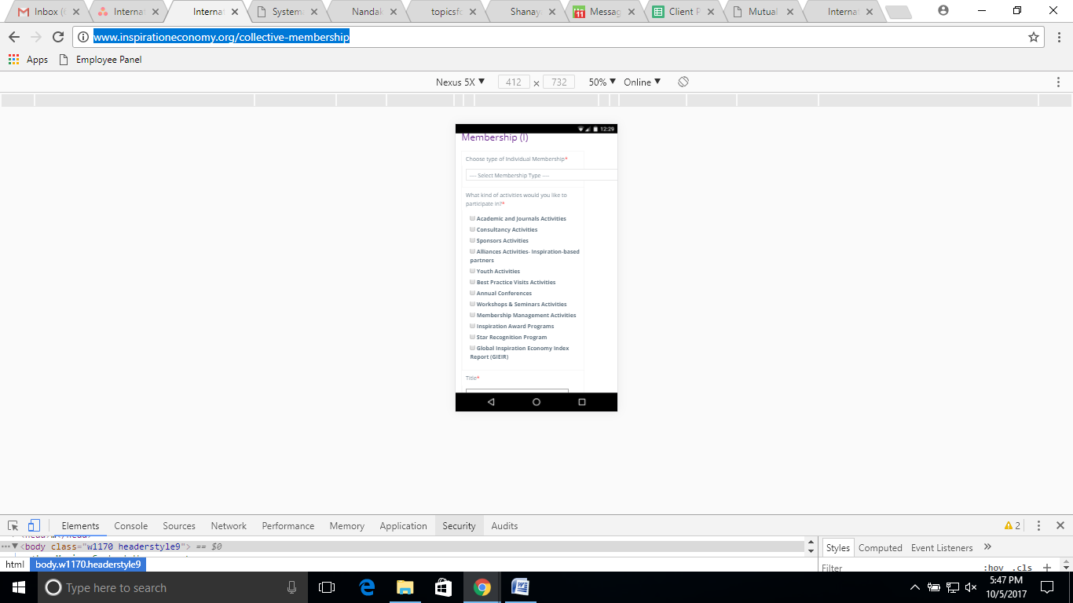

1. <http://www.inspirationeconomy.org/individual-membership>

Design not coming proper.



1. <http://www.inspirationeconomy.org/journals.php>

Content not coming proper.

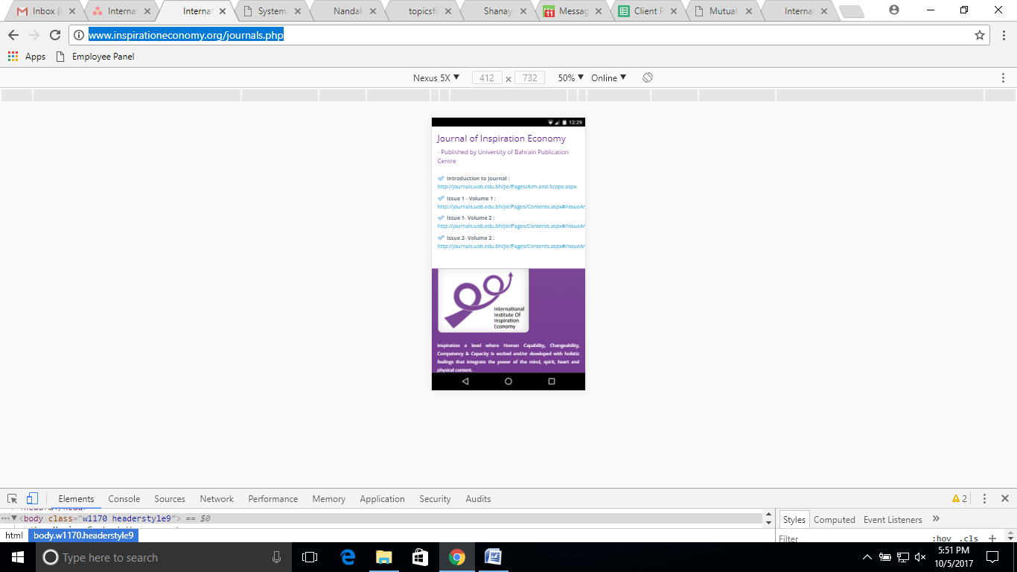

1. In the header the white strip in the banner should be removed from all the pages.