RESPONSIVE ISSUES

- In the entire website all the forms are not coming proper.
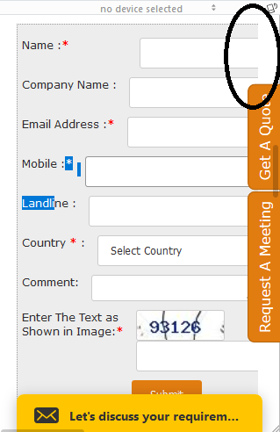
- On contact Us page also the forms in the pop up not coming proper also the design is breaking.
https://www.360website.net/contact-us.html
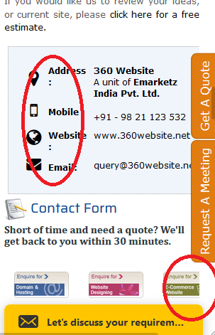

- Unnecessary blank space is coming.
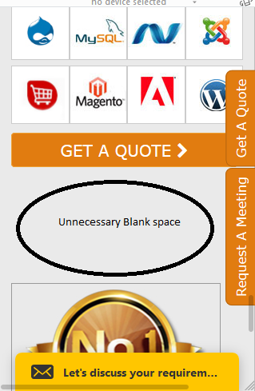
4. Form fields not aligned properly.
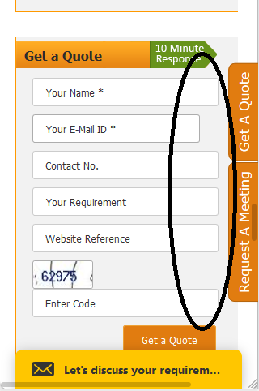

- Design not coming proper. Colour issues are there and arrows not coming proper.
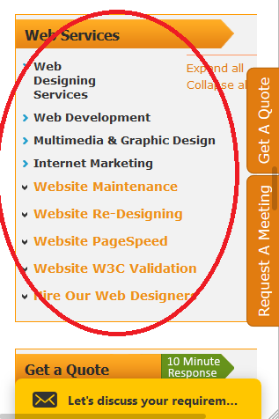
6. Design break. https://www.360website.net/services.html

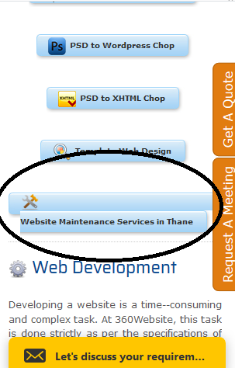

- Services should come in a box. https://www.360website.net/services.html
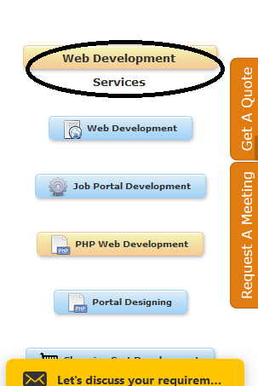
8. Design break on services page.
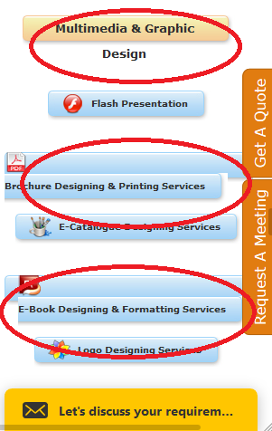

- Design is breaking on the inner services pages too. https://www.360website.net/brochure-designing-printing.html

10. https://www.360website.net/request-a-meeting.php This page is not at all responsive.
11. https://www.360website.net/portfolio.html This page not coming proper.

