# ****Crash Course to Get Published in SCI/SCOPUS Indexed Journal****

**WEEK 1**

**Day 1: Select 4-5 top journals in your target list:: 3rd June 2017**

Start reviewing latest articles from journals related to your domain which you are targeting. These could be from reputed SCI indexed journals.

Few journals are listed below:

|  |  |  |  |
| --- | --- | --- | --- |
| Human Resources | Computer Science | Communications | Wireless Sensor Networks |
| JOURNAL OF HUMAN RESOURCES | INTERNATIONAL JOURNAL OF FOUNDATIONS OF COMPUTER SCIENCE | INTERNATIONAL COMMUNICATIONS IN HEAT AND MASS TRANSFER | Ad Hoc & Sensor Wireless Networks |
| JOURNAL OF HOUSING ECONOMICS | JOURNAL OF COMPUTER SCIENCE AND TECHNOLOGY | INTERNATIONAL JOURNAL OF COMMUNICATION SYSTEMS | ACM Transactions on Sensor Networks |

**Human Resources**

**Day 2: Download Articles :: 4th June 2017**

1. Download few articles from the journal of your domain. Try to collect around 25 articles in the theme of your research.
2. Search articles published by the editor of the Journal you are targeting.

For instance, you target The Journal of Human Resources. Go the editorial board: <http://jhr.uwpress.org/site/misc/edboard.xhtml> and search articles published by its Editor.

**Day 3: Register in good impact factor journals to get more reputed sources :: 5th June 2017**

1. As under SCI Wiley have a good base of journals and very good journals published under it, register yourself with Wiley with no cost and start exploring the journals within your area.

Under Wiley for searching articles, below steps need to be followed:

* Go to Wiley
* Create account : Fill the form for creating account
* Login using your username and password
* Select your subject from where you can reach the list of journals under your domain. For instance, your research is in Electrical and Electronic Engineering, within this area, your research domain is Communication Technology. Go to list of journals under Communication technology where you can find journal <http://onlinelibrary.wiley.com/journal/10.1002/(ISSN)1099-1131>
* Go to its Editorial board and search names of Editors and the articles published by them.

1. Start downloading journals from these reputed journals. Contact us if you are unable to get suitable references. We will share few good journal articles without any cost.
2. Collecting latest 5 years articles is most suitable.

**Day 4/5/6/7: Start reviewing articles:: 6th-9th June 2017**

1. After downloading articles, start reviewing them and make notes on what you have studied from each paper.
2. Summarize each paper by pointing out few core points within the paper. Make a table with these points as mentioned below:

|  |  |  |  |  |  |  |  |  |  |
| --- | --- | --- | --- | --- | --- | --- | --- | --- | --- |
| **S No.** | **Author of Article** | **Title** | **Problem statement** | **Models/Methods used** | **Algorithm developed** | **Any comparison done** | **Platform** | **Outcome of study** | **Limitations of study** |
| 1 |  |  |  |  |  |  |  |  |  |
| 2 |  |  |  |  |  |  |  |  |  |
| 3 |  |  |  |  |  |  |  |  |  |
| 4 |  |  |  |  |  |  |  |  |  |
| 5 |  |  |  |  |  |  |  |  |  |
| 6 |  |  |  |  |  |  |  |  |  |
| 7 |  |  |  |  |  |  |  |  |  |
| 8 |  |  |  |  |  |  |  |  |  |
| 9 |  |  |  |  |  |  |  |  |  |
| 10 |  |  |  |  |  |  |  |  |  |

1. In one day, you can keep a target of reviewing minimum 6 articles. This way in 4 days, you will be able to review, 24 papers.

Second week: 10-16 June

Day 1: Zeroing down the papers

1. After you have reviewed the articles and developed an annotated literature review. Now you can start selecting articles which are close to the theme of your own research idea.
2. This could be done on the basis of what limitation every article had and how you can extend it further for a new research.
3. Start removing the articles from the list which might not be close to your research theme.

Day 2: Coming down to 4-5 articles

While zeroing down the number of articles, consider the final 4-5 papers in view of the following:

* What novelty did that paper introduce in the outcome
* What was the platform on which it was carried on
* Does the limitation has any further extension possible!
* What were the recommendations from the author!

Day 3: Drafting the design and approach followed in the finalized 4-5 papers.

You can zero down the articles as seen below:

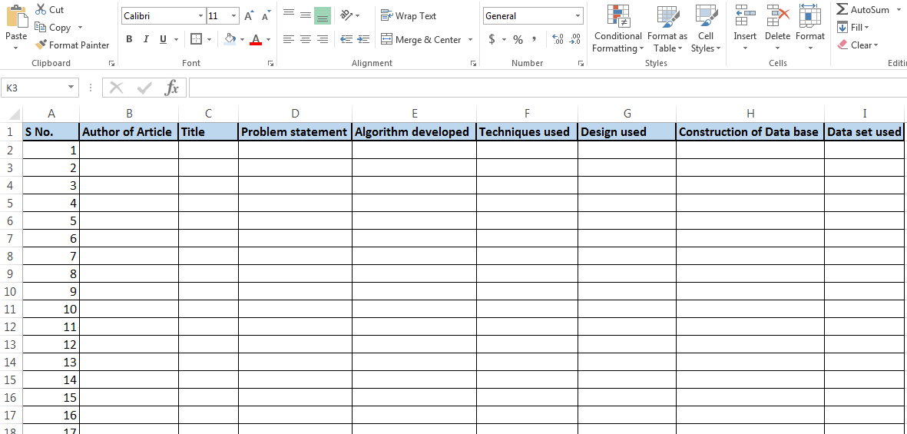

Day 4 & 5: Finalising 1-2 base papers

1. While you have zeroed down 4-5 papers, you still need to be sure of the exact problem on which you can work and the type of data set applied on the same.
2. Come down to 1-2 articles basis the suitability of data set used in that research and techniques known to you.
3. While you are sure of the data set construction or complete availability of the data set applicable, you can finalize the base paper(s)

Day 6 & 7: Developing research gap/problem statement

1. While you are aware of the design/method, approach and techniques to be used. You can formulate the final problem stating the extension your study will be based at.

For instance:

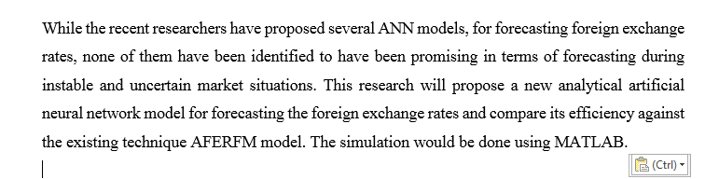

1. You problem should have three elements:

* What did you review from previous researches
* What novelty your study will include
* Which platform will it be worked on

Third week : 17 june – 23 June

Day 1 & 2: Finalizing concrete details of research

1. Once the problem is developed or you have the research gap, you will now be able to finalize the plan of implementation.
2. First and foremost information within the plan will include the following:

|  |  |  |
| --- | --- | --- |
| Area | Computer Science/IT/Engineering | Management/Medical |
| Stage I | Requirements during the implementation process | Research paper layout |
| Inclusions | Tool/Platform for implementation | Research background |
| Approach to be followed | Formulating objectives |
| Techniques/Algorithms | Defining the Parameters/Materials/Variables |
| Stages of work | Formulating hypothesis : Null and Alternate |

Day 3 & 4: Developing the design for research

|  |  |  |
| --- | --- | --- |
| **Area** | **Computer Science/IT/Engineering** | **Management/Medical** |
| **Stage II** | **Concept/Model on which research is based** | **Developing research design** |
| **Inclusions** | Identification of Datasets to be used | Research strategy |
| Data collection sources | Types of research to be employed |
| Inputs Required for implementation | Data collection methods and strategy |

Day 5, 6 & 7: Developing Module and Flow chart of process

|  |  |  |
| --- | --- | --- |
| **Area** | **Computer Science/IT/Engineering** | **Management/Medical** |
| **Stage II** | Modules covered in the process | Research Design Contd... |
| **Inclusions** | Division of phases as per objectives/stages of work | Data analysis methods and strategy |
| Expected output/outcome | Data management tools & procedures |
| Steps to be followed at each stage | Sampling methods |
| Selection of optimum techniques for research | Rating scales and type of scales to be employed for data collection |
| Developing a Flow chart of process | Developing plan of hypothesis acceptance and rejection as per objectives |

Week 4: Implementation/ Questionnaire development : 24 to 30 june

Day 1 & 2: Gathering Data/ Questionnaire design

1. You need to spend time in gathering data required for research work. While, there are different research domain, different types of data sources and tools are involved.
2. For instance, research is in domain of image processing, data set applicable here will be of images which can be medical images/traffic images or any particular images as per the research.

On the other hand, data set in a research related to consumer behavior will be collected by survey done to consumers of any particular product (target respondent). This data collection/survey can be done using Questionnaire which can be developed basis the variables and the profile of target respondents.

While you might be stuck in deciding the types of images in your research or which will be the target respondents and what type of questionnaire will be needed, you can approach us for any support or query on the same.

Day 3, 4 & 5: Deciding techniques/Developing the tool for data collection

1. While searching data for the research, you need to consider the domain from where data set will be used. For example the research is based on eye retina images or x-ray images, which means medical images data will be applicable. On the other hand if research is based on object identification within image processing where we need to detect image of car from a road images data, in this case, traffic images data will be applicable, which can be retrieved from traffic circuit cameras.
2. There could be various sources from where data can be gathered, it can be hospital data in case of medical images and data collected from traffic control department for the object detection research as mentioned above.
3. Once the data is collected in desired format, you can start working on finding the techniques which can be used on this data set.
4. For instance, expected outcome of your research is reducing noise in image and further enhancement, you can apply techniques which can help in denoising. Techniques like Median, Low pass filter, high pass filter can be used, which are few known filtering techniques.

You need to apply equations and do coding while working on these techniques on the data set.

|  |  |
| --- | --- |
| Image processing domain | Consumer Behavior |
| 1. While searching data for the research, you need to consider the domain from where data set will be used. For example the research is based on eye retina images or x-ray images, which means medical images data will be applicable. On the other hand if research is based on object identification within image processing where we need to detect image of car from a road images data, in this case, traffic images data will be applicable, which can be retrieved from traffic circuit cameras. 2. There could be various sources from where data can be gathered, it can be hospital data in case of medical images and data collected from traffic control department for the object detection research as mentioned above. | 1. Developing demographics of the target respondents.   Demographics of respondents need to be developed basis the profile of respondents you will be interviewing and which details of the respondent are relevant for the study to be known and analyzed.   1. Designing the structure of questionnaire basis the types of questions suitable to get the answers which could be rank based questions, likert scale, multiple choice and priority based questions. |

Day 6 & 7: Deciding techniques/Developing the tool for data collection. Contd...

|  |  |
| --- | --- |
| Image processing | Consumer behavior |
| 1. Once the data is collected in desired format, you can start working on finding the techniques which can be used on this data set. 2. For instance, expected outcome of your research is reducing noise in image and further enhancement, you can apply techniques which can help in denoising. 3. Techniques like Median, Low pass filter, high pass filter can be used, which are few known filtering techniques.   You need to apply equations and do coding while working on these techniques on the data set. | 1. Start developing relationship of variables according to which questions can be framed. 2. Questions should be designed in a way that they are able to cover all objectives of the study. 3. While developing of questionnaire is done, it is important to get it validated/check reliability through Cronbach Alpha test/Pilot study. Validity test can be done using 30-40 samples of data. |

Not all may be aware of varied techniques applicable for denoising/enhancement. Also, it might be that you may not have a hands on experience on SPSS where validity test can be conducted. You can reach us out in case you need any support during this week. You can call us at 011-48111144/9818867733.

Week 5: 1 july- 7 july

Let us reiterate first where we have reached so far.

**Image processing domain:**

To reiterate, we took example of image processing topic wherein we will be doing denoising and image enhancement. While your data set is ready and you have finalized that you will be applying filtering techniques which will be applied to the data set, you can start with the first phase of work.

**Consumer behavior:**

We had already developed the questionnaire, so now you can allow yourself this entire week for collecting data. You need to collect around 30-40 samples first for conducting validity test.

**Phase I of Implementation**

Recognizing noise – Researching on Filtering Techniques – Applying techniques

**Day 1 & 2: Recognizing noise**

While you have selected the filtering techniques, you need to recognize the type of noise is present in the images. A few sources of image noise are mentioned below:

* Image may be affected by environmental conditions while image acquisition
* While scanning, some particles may be present which can introduce noise to image

Some noises can be classified as below:

* Film grain
* Isotropic noise
* Multiplicative noise
* Quantization noise
* Multiplicative noise

Once the noise form is recognized, you can start working on filtering techniques suitable for denoising the image. Some techniques mentioned were Median, Low pass filter, High pass filter.

As our team has experts from the domain of image processing and other areas, you can reach us out in case you need any support for recognizing noise/issues in the data set. We can review and support you in the same.

**Day 2, 3 & 4: Research on Filtering techniques**

Once the noise form is recognized, you can start working on filtering techniques suitable for denoising the image.

Image denoising is very important task before we can enhance the image. As there are many filtering techniques/algorithms available, you can select the best one for completely removing the noise. There is one more way in denoising filtter can be classified:

Linear method and non-linear method.

Liner method: It works at a fast pace while denoising image. However, with one disadvantage that it doesn’t retain the details of images.

Non liner method: This is one method which denoises as well as retains the details of images as well.

Some filters are listed below:

* Mean filter
* Median Filter
* Order static
* Adaptive filter

**Day 5, 6 & 7: Applying filtering techniques**

While you are aware of various filtering techniques, you can apply few techniques on the same data set and compare which technique produces better results.

The results which you expect should have the details of images in tact with denoising sorted in the images. Once you are through this stage, you can look for further enhancement in next phase of work.

It might be a possibility that you do not have hands on experience in working on Matlab or have known how to apply these techniques. Our team can support you on how these you can finalise/select a technique and further apply.

Feel free to contact us at info@phdbox.edu.in

Week 6: 8- 14 july

Let us reiterate first where we have reached so far.

**Image processing domain:**

To reiterate, we were working in the domain of image processing topic wherein we will be doing denoising and image enhancement. While your data set is ready and you have applied filtering techniques which resulted in denoising of the images in data set.

**Consumer behavior:**

As you have been working on data collection for pilot study, by now probably the data must be ready. It can be 30 -40 samples only using which, we can do validity test.

**Day 1 & 2: Retaining images’ details intact/Reliability analysis**

**Image processing**

Once the images are denoised, we need to first look at the quality of details of images being intact.

There are methods using which you can recognize whether the denoised image is better than the original image. A measure of MSE(mean squared error) can help you evaluate whether there is difference in denoised and noisy image.

A Low MSE would mean that denoised image is same as noisy image and this shows that denoised image is still noisy. This shows, algorithm with large MSE is better. It means if you use high MSE algorithm, we are able to achieve good quality denoised image.

**Consumer behavior**

Before you start working on reliability test, you should be aware why this is important and relevant for your research.

Before we proceed for analysis, we need to check if the scale is consistently reflecting the construct. When two observations are equal in terms of construct being measured, we need to use reliability test.

While you are using SPSS, you can follow the process as below:

1. From top menu, click analyze, scale and then click on reliability analysis.
2. Transfer variables into the items
3. Keep the model set at Alpha
4. Click on Statistics

Few points to remember for Cronbach’s Alpha:

1. Coefficient ranges between 0 and 1.
2. If the coefficient is closer to 1.0, greater is internal consistency of the items in the scale.
3. Cronbach’s alpha coefficient increases if the number of items increase or as average inter item correlations increase.

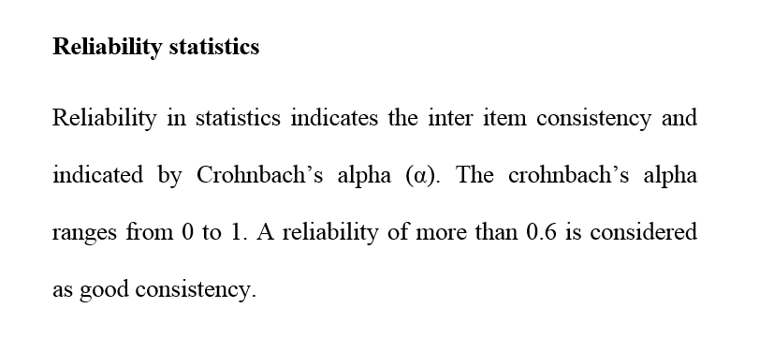

**Day 3 & 4: Recognizing Image enhancement techniques**

**Image processing**

1. Make a list of image enhancement algorithms/techniques which are likely to be adapted. A few are mentioned below:

* Contrast stretching
* Histogram Equalization
* Negative image transformation
* Power law transformation
* Decorrelation stretch
* Contrast limited adaptive histogram equalization

1. You can now finalise as per the image denoising done that which type of image enhancement technique will be suitable for better results

**Consumer behavior**

Once you have transferred the variables into the items. Now you can perform Cronbach’s alpha test.

**Day 5, 6 & 7: Applying image enhancement/Cronbach’s alpha test**

**Image processing**

Post you have identified the enhancement techniques you can decide on the process to be followed for the same. Most commonly, in image processing researches morphological operations or fuzzy logic techniques are used for enhancement.

Based on outcome we expect, we can enhance the number of pixels. Grouping the pixels, improvises quality. Once this is done, formulation of mathematic modelling/equations is done, which is called as coding. This process takes time. While you are running the data set and applying mathematical formulations.

**Consumer behavior**

You can perform Cronbach’s alpha and see the score of reliability of the questionnaire. The results are represented in the following format.

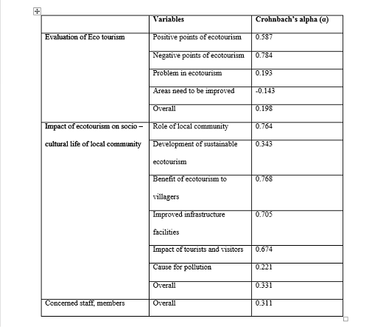

Now as can be seen, score above 0.6 is considered as good, however, below 0.6 are deemed to be poor. This results in overall Cronbach’s alpha value which is low and very poor.

If the reliability test gives poor results, it shows a need of shift in the scale in the questionnaire, while score above 0.6 shows appropriate questionnaire scales.

While working on the reliability test or getting understanding on which technique for enhancement should be applicable, you might come across some doubts or queries. Feel free to contact us for the same at 9818867733/011-48111144.

Reiteration:

**Image Processing Domain:**

Denoising of images was done using Filtering techniques. We decided on the enhancement techniques on denoised images. For this the data set was ready and we started working on mathematical equations.

**Consumer Behavior:**

Reliability test was conducted on a set of 30-40 samples collected using the questionnaire we developed. We had the results for reliability test which tell us the score on the reliability of the questionnaire.

**Week 7: 15 july- 21 july, 22 july – 28 july, 29 July – 4 August**

**Image processing**

This week is mostly occupied in running the data set using the enhancement techniques and applying mathematical modelling on the same. This process may take a week or two for generating results basis the coding done.

Coding and the development part which is done in this week is the most crucial part of your research and which cannot be explained in a process. You should have hands on experience in coding and applying techniques to a data set for enhancement in images.

During this stage, you might feel maximum need of taking help from a consultant. Do feel free to reach us if you are stuck and are looking for some support.

**Consumer Behaviour:**

While the reliability test is conducted and you have the score, in case the score comes more above 0.6, for sure you are on the right track.

On the other hand, in case the test show score below 0.6, there is a definite need to reframe or reset the questionnaire as it may not help you in getting right results as per the outcomes.

**In the first case,** **when the score is 0.6 or more**, you can start working on the data collection. While your sample size is decided, you can reach out the respondents through following ways:

1. **Survey Monkey method**: You can use this online tool for collecting data samples. You can upload your questionnaire on this online tool, add contacts and you will keep on getting responses. Visit it at <https://www.surveymonkey.com/>
2. **Face to face Survey**: While you have sources through which face to face survey is possible, this is one method that you can follow in case a huge sample size is not to be worked on.
3. **Approach respondents via email**: You can send an online questionnaire to a list of contacts over emails and get responses.
4. **Telephonic interviews**: This is also a method possible in case you are able to approach respondents through this method.
5. **Group discussions:** These is generally possible in case of open ended questionnaire/qualitative questionnaire.
6. **Observation method**: This can be applicable in studies where you need to collect data through observation on the particular target respondents or section of society.

Once you are indulged in data collection, it may take you one or two or more weeks for collecting data.

**In case, score is less than 0.6,** it indicates that probably questionnaire is not satisfying the conditions required for getting right type of data from respondents.

When a section of the questionnaire has a very low score, it needs to be modified so that it can help in getting right responses as per the expected outcome.

This is crucial when you need to re-develop the questions, keeping in view that now it fulfills the expected outcomes.

This is how, this and the next week will be spent. We will be back with another set of suggestions by next week. Just in case you need a support on anything, reach us out at 011-48111144 or 9818867733.

**Week 10:**

We are back with inputs on the process of SCI paper development.

**Reiteration:**

Last time when the update was sent, the stages you had to cover in the past 2 weeks were:

**Image processing**

* Mathematical Modelling
* Coding/Simulation
* Applied techniques for enhancement of images

**Consumer Behavior**

* Final results of reliability test
* Data collection for final analysis

**Next plan:**

**Image processing**

While the enhancement of images is done, we have the final code and results with us. Now is the time when you need to have the correct environment and run the code.

As it is Matlab implementation, while running the code, you should be sure on which toolbox/functions under which the code has to be run. Some of the functions for image enhancement in Matlab are mentioned below:

* Imfilter
* Imgaussfit
* Fsspecial
* Fibermatic
* Imboxfilt

While implementing is done, running the code successfully is the challenge. You might face issues while running the code as some functions might not be working. This is one of the reasons that scholars look for support from developers who can assist in conducting implementation. You can reach us out just in case you need a support at [info@phdbox.edu.in](mailto:info@phdbox.edu.in)

Post this is done, you can proceed for writing of paper.

**Consumer Behavior**

**Stage I: Data Entry**

While the data is ready with us in form of questionnaires, the same need to be entered in excel sheet in coded format. The following represent how data sheet is developed:

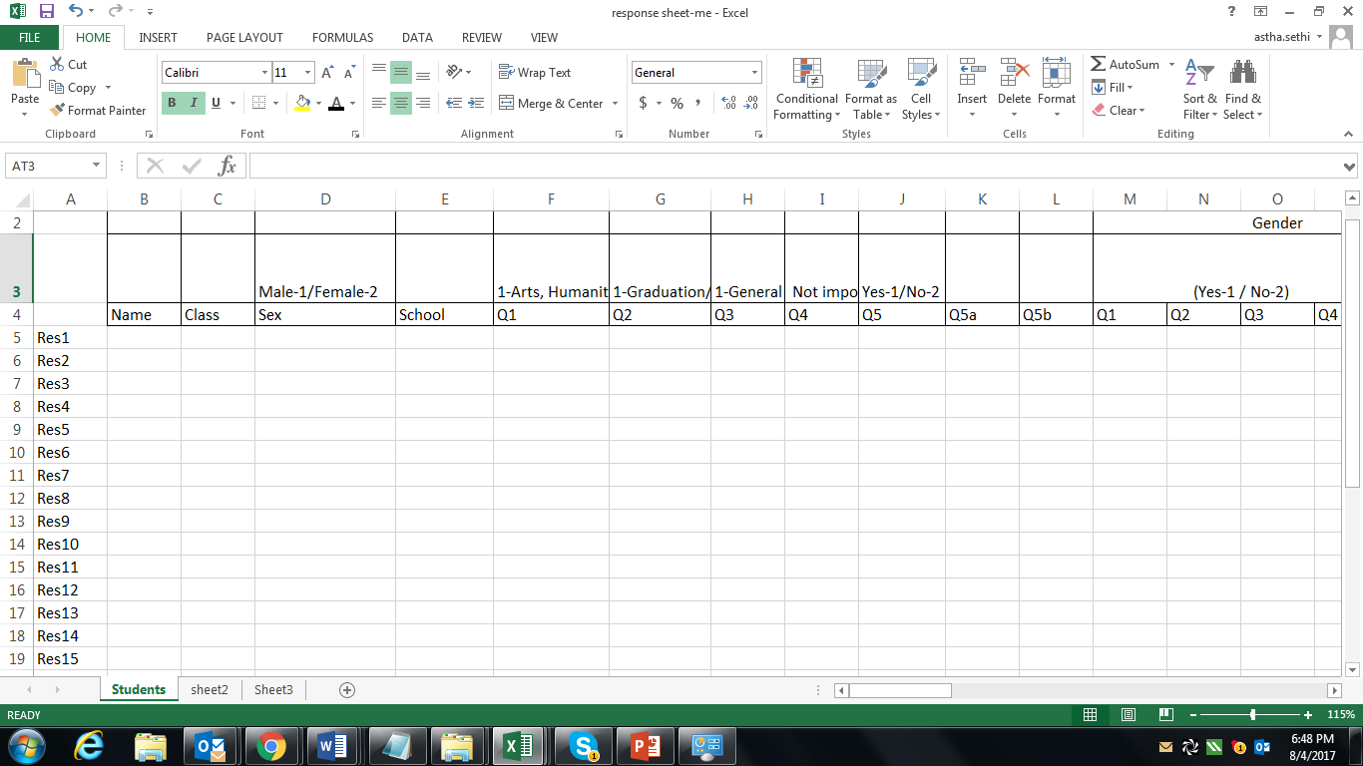

You need to enter data in this format:

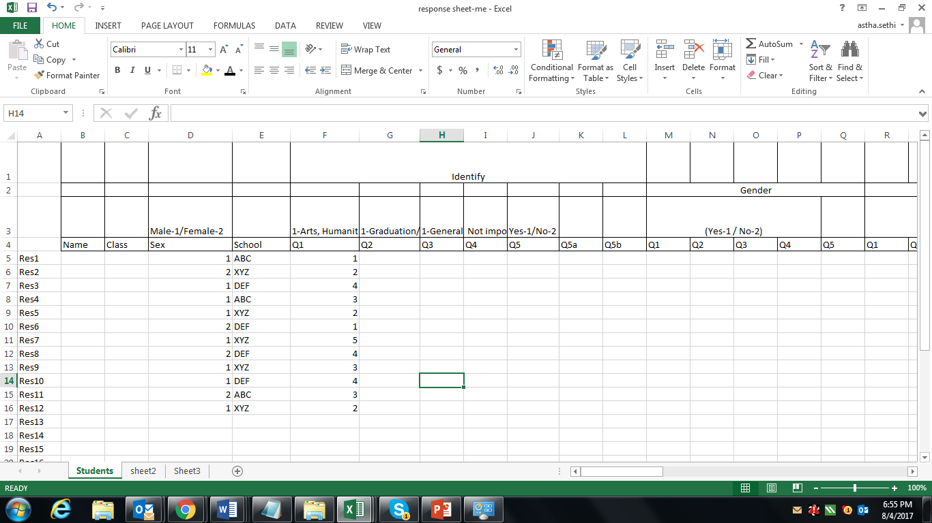

Stage II : Applying tests

Once the data is entered, you can enter it in SPSS software for analysis. Quantitative analysis will be done on this data which includes following:

* Descriptive analysis
* Inferential/Factor analysis
* Hypothesis testing

Under statistical analysis, varied test are applicable as per the type of variables of the study. Some of the tests are named as below:

* Chi Square test
* T- Test
* Spearman rank correlation test
* Z Test
* Correlation
* Regression

Stage III : Getting results

Post you apply suitable tests, analysis results are visible like this:

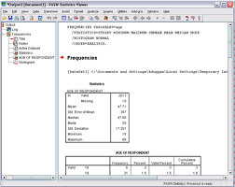

Stage IV: Interpretation of results

Interpretation of results is presented in following format:

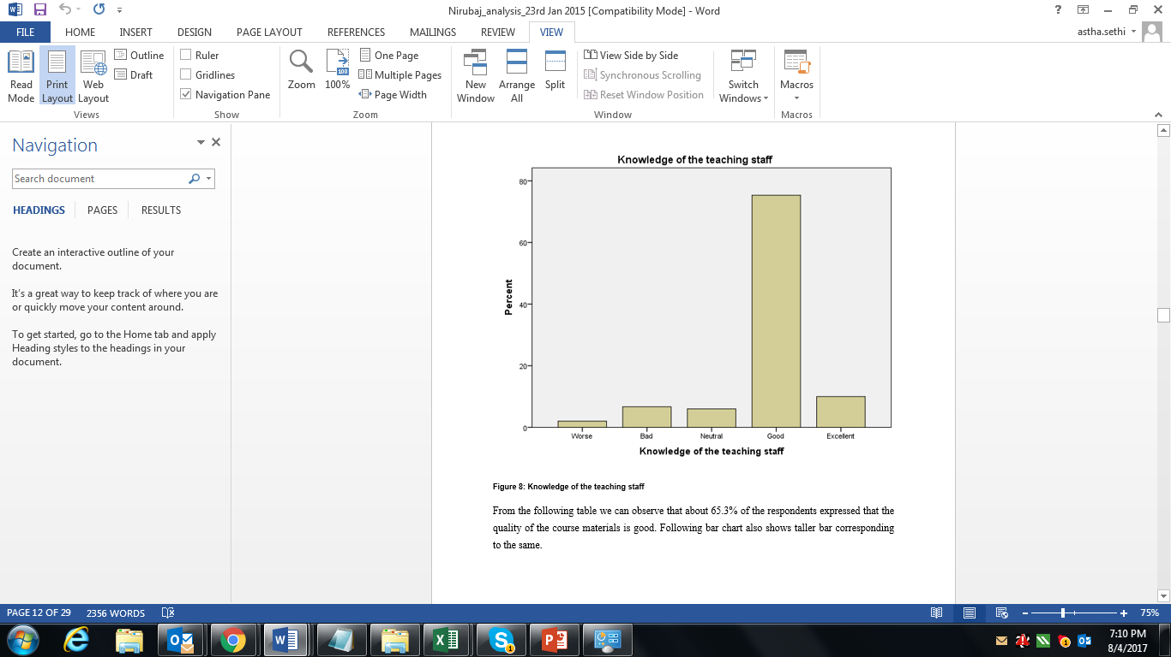

This is how in this week, you can plan to complete analysis, so that from next week, you are on with writing.

Feel free to reach us at 9818867733 or at [info@phdbox.edu.in](mailto:info@phdbox.edu.in)

Week 11: Writing Research Paper

**Reiteration:**

We have by now completed the following:

Image Processing:

1. Coding completed
2. Creating environment
3. Running the code

Consumer Behavior:

1. Data entered in Excel
2. SPSS analysis done
3. Interpretation done

Next plan:

Research paper writing starts from here. While you start writing research paper, keep in view following points:

1. You have all the references collected which you will review while writing paper.
2. Make a plan of references to be reviewed and which key points to be mentioned while writing or summarizing the papers.
3. Prepare a layout of paper in a way that sections and subsections are divided and planned.
4. Post layout is developed, now you can start writing on the first few sections which are based on review
5. The sections Methodology, Results and Conclusions will be based on the implementation methods and techniques used and the results.
6. The section of results should include some screenshots of graphs of results which were in the Matlab outcome.
7. Conclude the paper with details on what study you conducted, how it adds value to the domain and suggest few recommendations for future researchers.

As writing of research paper needs to be academic, a touch of peer review or academic editing may also help post you have drafted the paper.

Reach us out at [info@phdbox.edu.in](mailto:info@phdbox.edu.in) in case any support needed while you write the paper or if you need some references help.

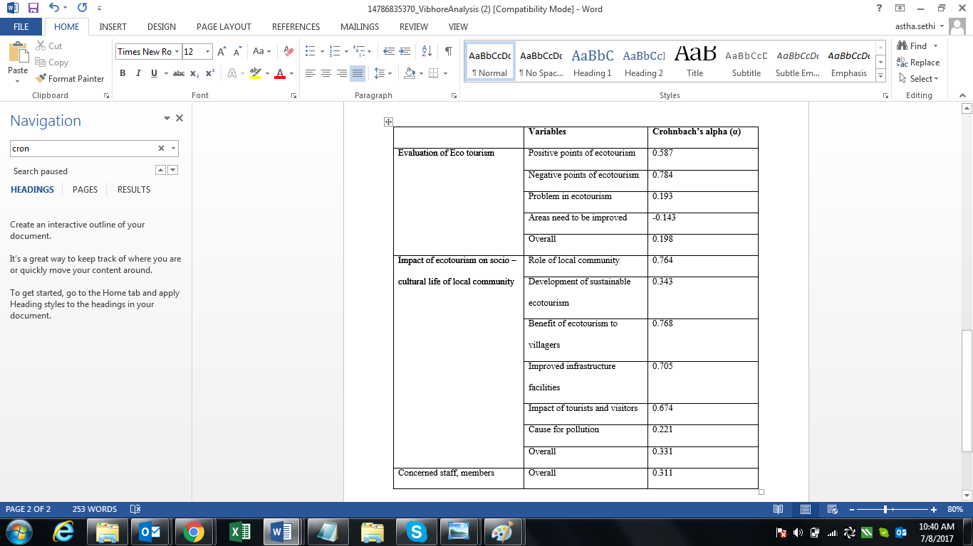

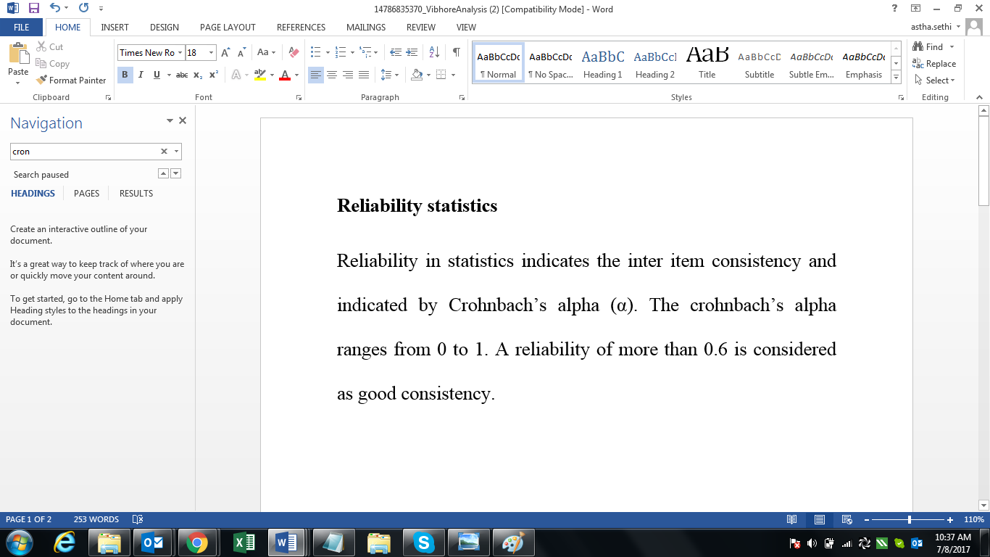

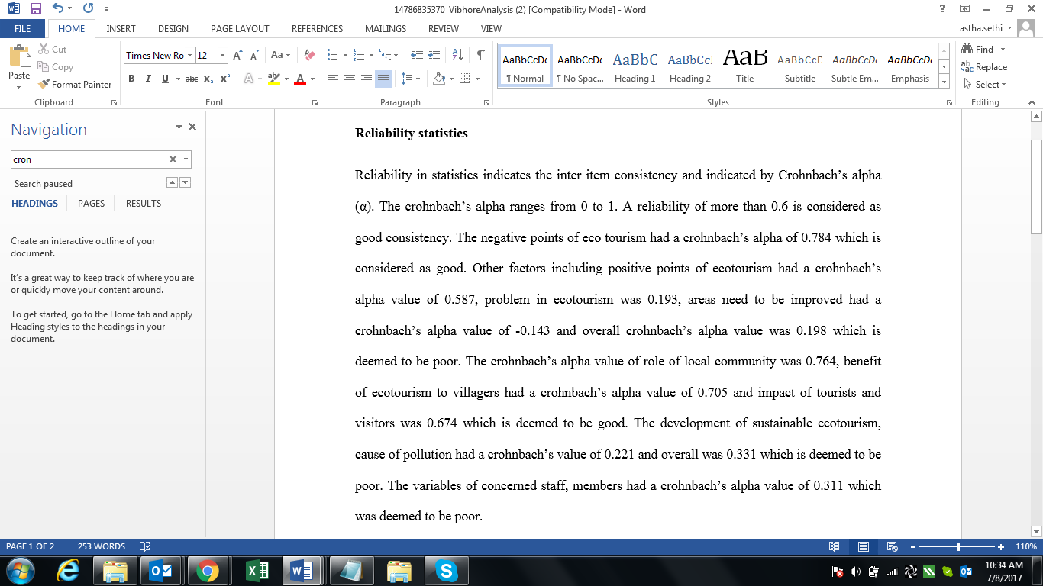

* Title
* Problem of the study conducted
* Model/Methods used in the study
* Data sets used by the particular study and how was the data set collected
* Which Algorithm was developed in the study
* Was there any comparison between different algorithms in the study
* Which platform was used for implementation
* How the results were summarized and what was the outcome of the study
* Were there any limitations to the study

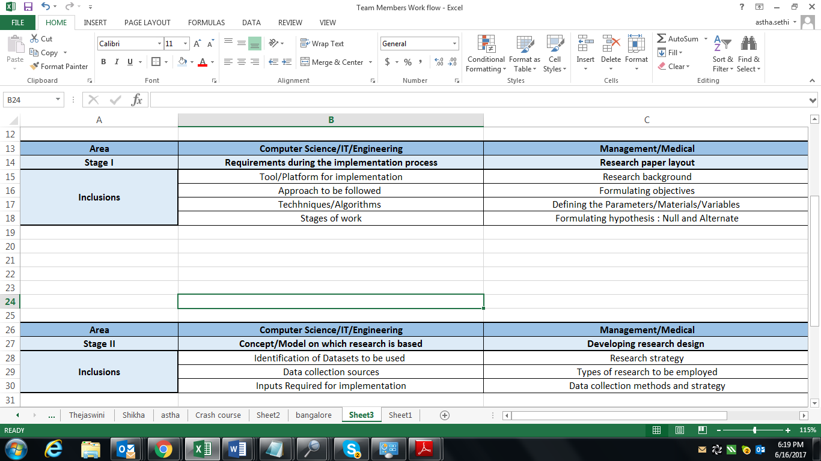

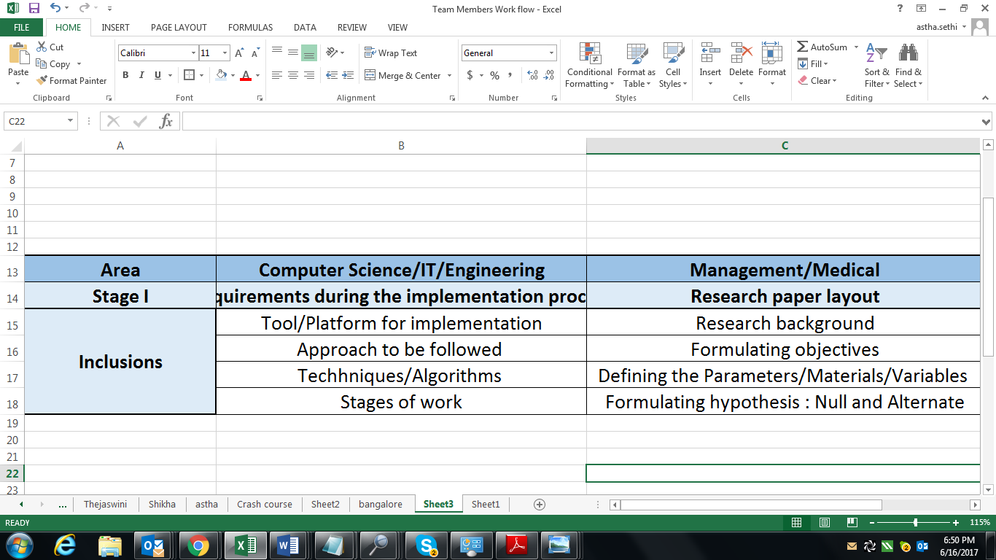

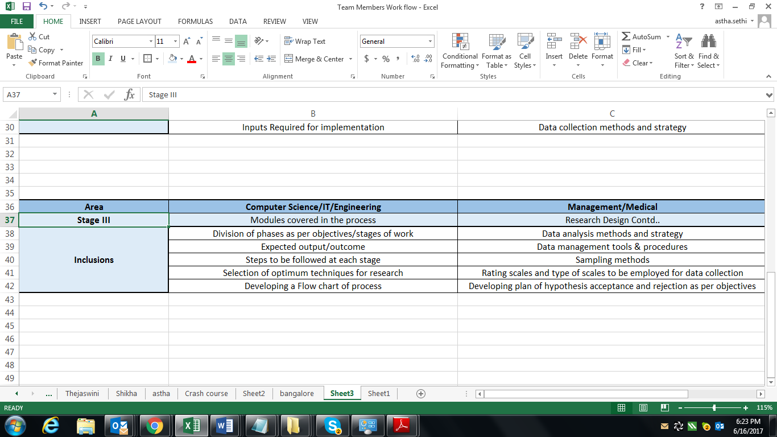

Reviewing papers from similar domain

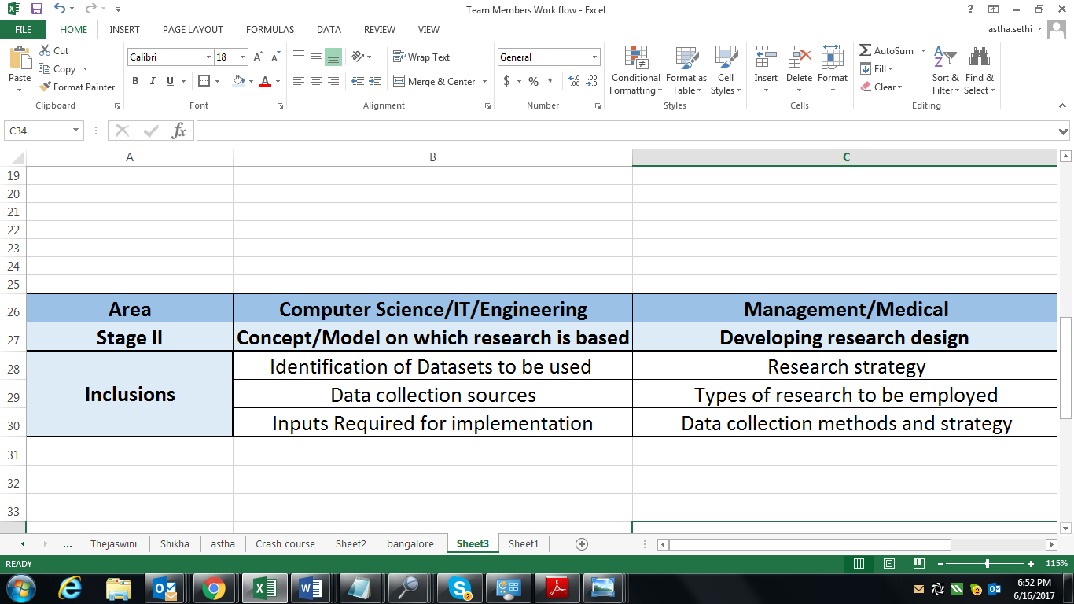

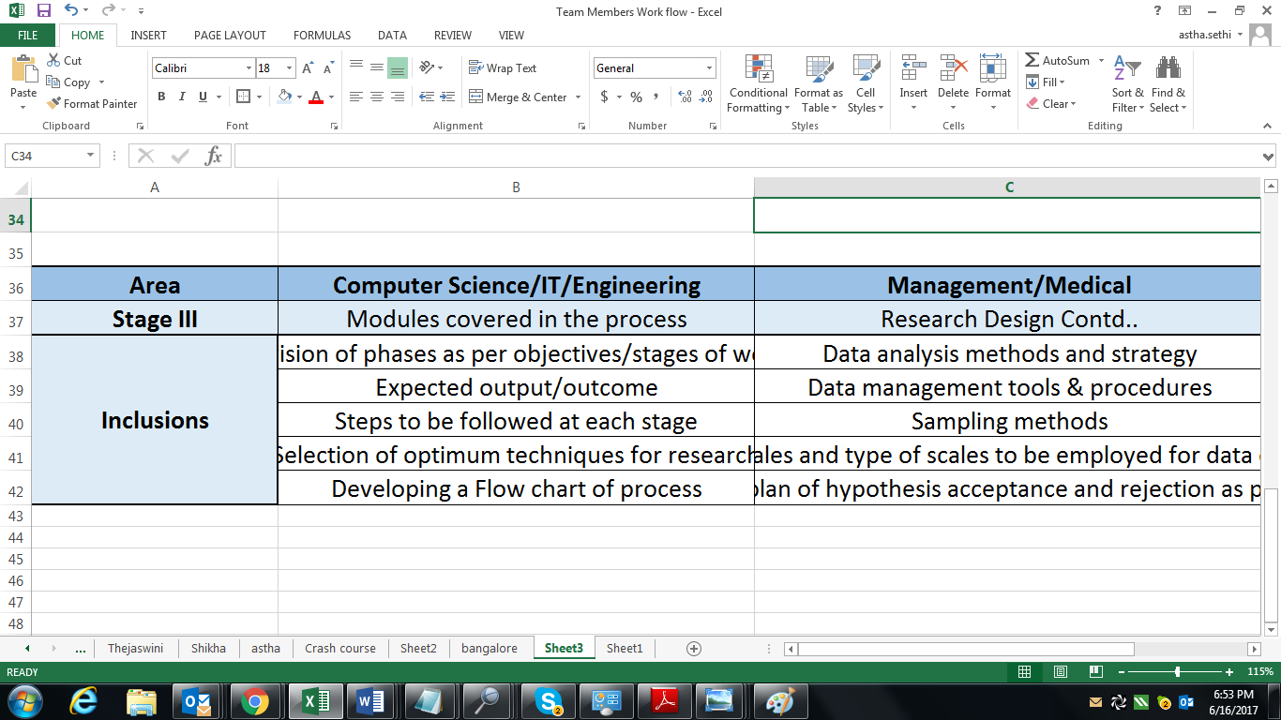

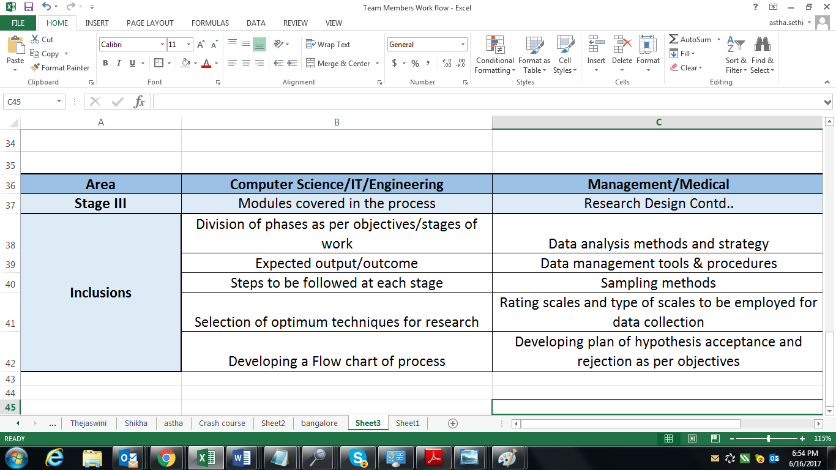

Finalising one to two Base paper

Formulating problem from the base paper(s)

Deciding the extension from the problem

Review and research on Problem being novel for a new research

Formulating an implementation plan which includes information on Data sets, algorithm, and techniques to be used

Software Implementation

Manuscript writing

Formatting

Submission to Journal

