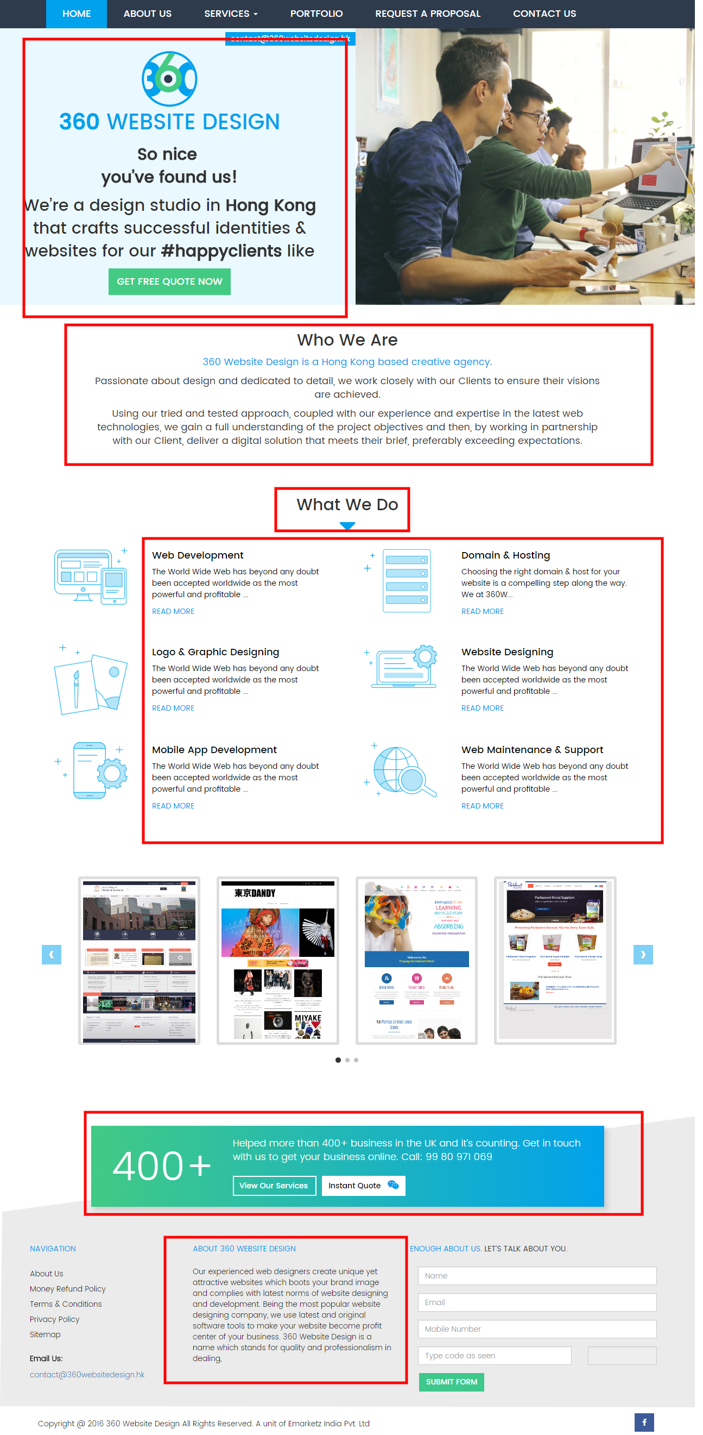

|  |
| --- |
| ***Want an intuitive website for your business?***  ***We can help****!* |

|  |
| --- |
| **Get to Know Us**  ***360 Website Design***  ***Where we develop innovating strategies to drive your business more revenue***  We offer website designing and development services in Hong Kong for building a website appealing to your target market. From planning to executing ideas, our professionals ensure that nothing is left underdeveloped in your website. |

***Our Services: A Quick Glance***

|  |  |
| --- | --- |
| ***Web Development***  *Let us bring your business ideas into digital life through our web development services.* | ***Website Designing***  *Hook your target audience to your market with a custom web design and layout full of interactivity and relevancy.* |
| ***Logo & Graphic Designing***  *Is your corporate website newbie to the world of internet? Let us help in building your business as a brand with customized logo.* | ***Domain & Hosting***  *Give your website a unique identity and adequate space on internet with our domain and hosting services.* |
| ***Mobile App Development***  *Increase the customer visibility of your business with your own mobile accessible to millions of users worldwide.* | ***Web Maintenance & Support***  *Need to revive your old website? We turn your dull website into a vivid one with interactive design and features.* |

|  |
| --- |
| Successfully developed more than 200 hundred websites across Hong Kong. Know why people are choosing our services or if you already know that, let the time not slip away! Get instant quote today!  **Get Instant Quote**  **View Services** |

**200+**

|  |
| --- |
| **About Us**  We are based in Hong Kong and deliver website designing and development services across the globe since 2013. We have separate teams of Web Developers, Web Designers, Graphic Designers, Web Analysts, and Content Writers for producing a website suitable for client’s target market. Currently, we have 147 people working with us in a united team. |