

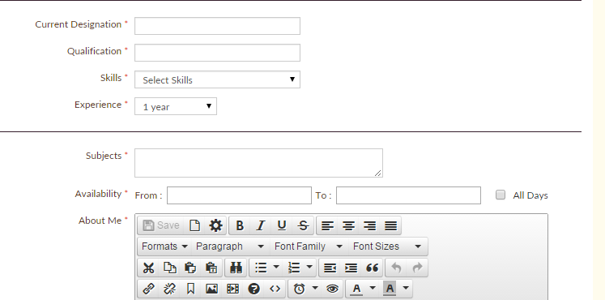
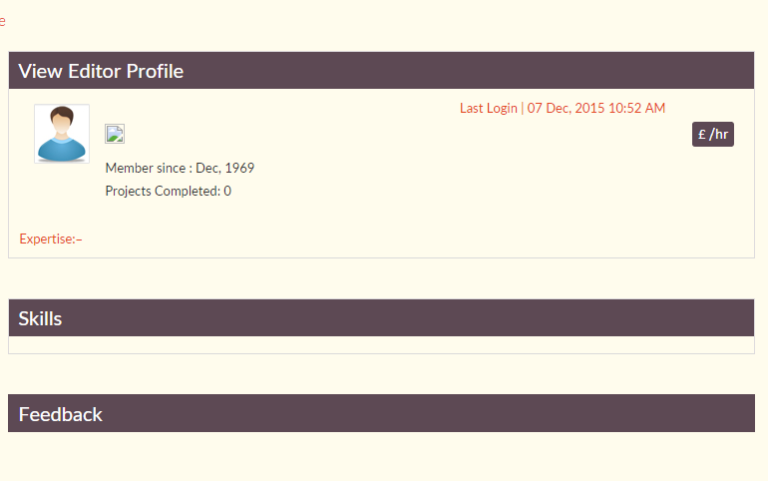
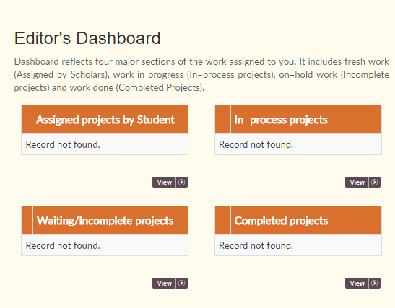
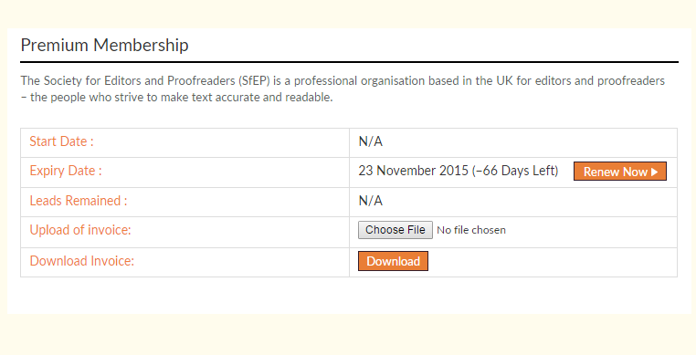
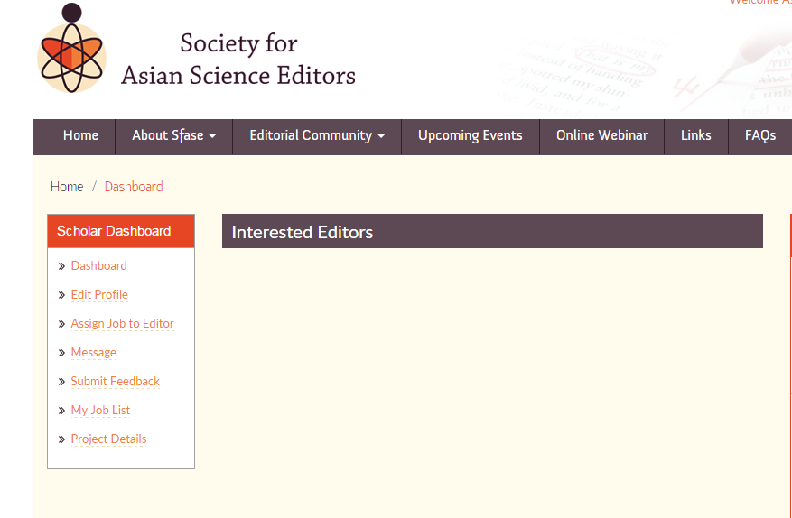
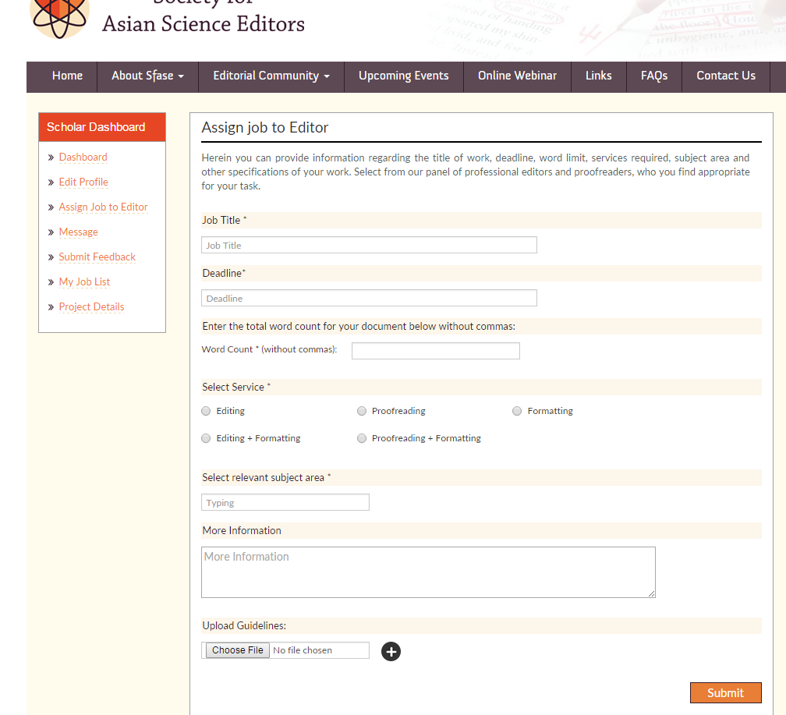
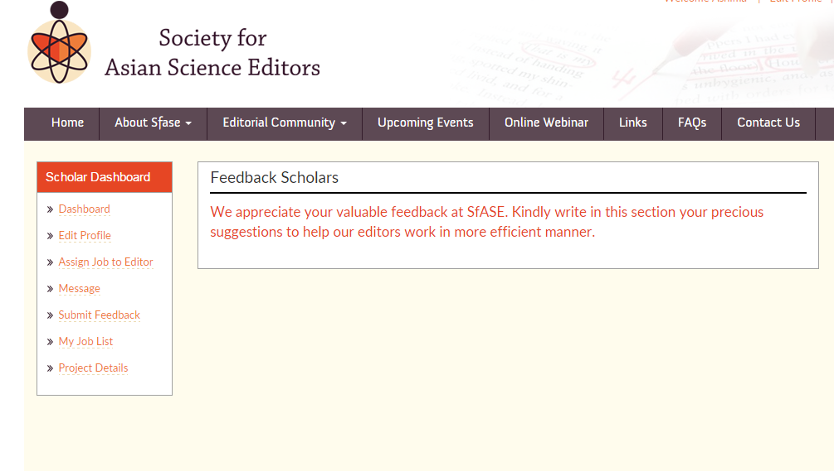
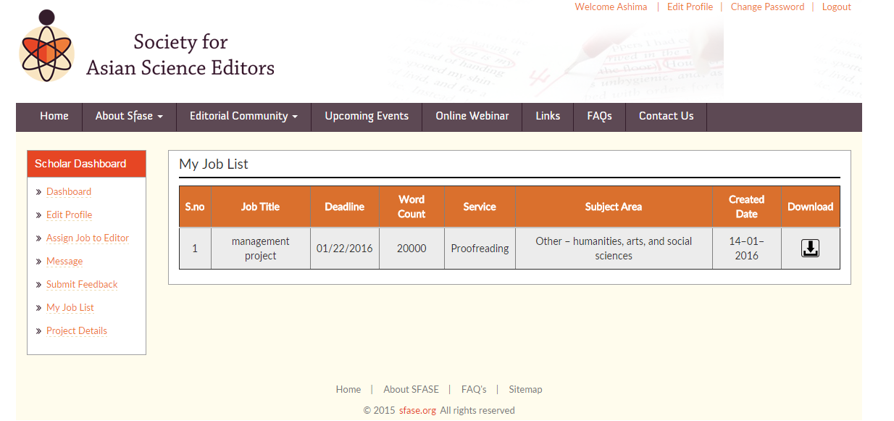
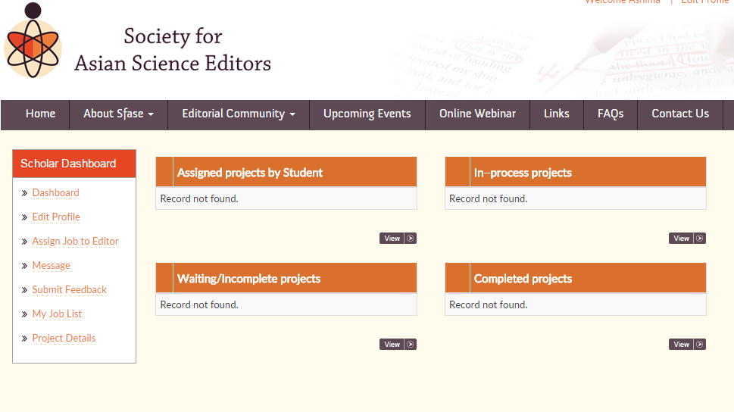
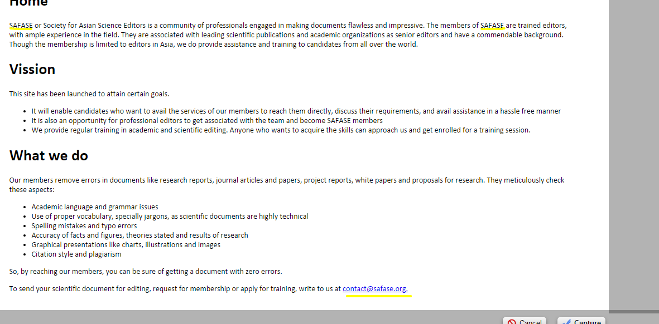
- SfASE Home page http://www.sfase.org/test/index.php
Find editor of your choice
Select a subject specific editor to complete your work
Read our FAQ’s

- SfASE Join us Page (http://www.sfase.org/test/join-us.php)
The Editor sign up should come first.

- Editor’s profile (http://www.sfase.org/test/writer.php)
Current Designation should be changed to Work Experience
A link of Difference between editing and proofreading (FAQ’s page) can be placed next skills.
Experience (Spelling error): Should be corrected to 2 years, 3 years, 4 years and so on.
Availability: it allows me to select a date from the past. Why so?
When I tick mark at All Days, the selected dates go missing.
- Editor’s Public Profile (http://www.sfase.org/test/view-public-profile.php)

The price must be in dollars and last login details are incorrect.
Skills are not visible.
- Editor’s Dashboard (http://www.sfase.org/test/dashboard.php)
These headers must be changed to: New Projects in place of Assigned projects by student
On-going projects in place of In-process projects
On hold projects in place of In Waiting/Incomplete Project

- Membership (http://www.sfase.org/test/membership.php)
Society for Asian Science Editors offers an opportunity to editors from Asia to join us and enjoy the benefits of our premium membership plan.
On what basis the number of days are calculated? It should be at least 1 year.

- The following pages are required to be removed from the website:
- Membership Plans : http://www.sfase.org/test/membership-plans.php
- Upcoming Events: http://www.sfase.org/test/upcoming-events.php
- Links: http://www.sfase.org/test/links.php
- The word student must be replace with SCHOLAR in the entire website.

- Student’s Dashboard

This should be replace with: Suitable Editors for your work
- Assign jobs to Editors

More services can be added to this section.

- Student Feedback:
Where should I write and submit my feedback??
- My job list

My job List should be changed to Project assigned by me or Projects uploaded by me

- Project Details :
- Replace Assigned projects by student to Projects uploaded

- Home page (http://www.sfase.org/)
SfASE should be written in place of safase.

