Redmarkediting Testing

Home page (http://www.redmarkediting.com/)

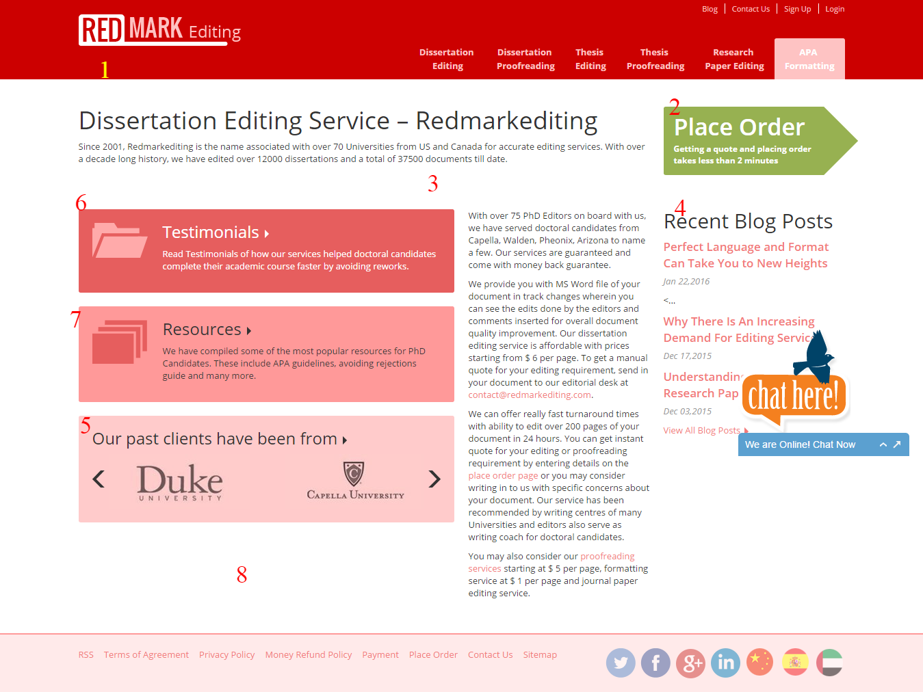

1. The logo seems to be hanging up. Align it in the center. The font size for **Editing** (in logo) should be in sync with Red mark. Also a tagline can be added below: Affordable editing services!
2. Place order looks very ordinary. As a user, I don’t realize that I have to click on it to place an order. So we can interchange the hover color with the basic one. Also play button can be added to this section renaming it as Get Instant Code.
3. This white gap is very disturbing for the reader. We can add content to remove this white gap.
4. Recent blog post can be renamed to From Editor’s Corner and this will shift to right corner bottom.
5. Our past clients will be re-designed by improving the background color and will be shifted in place of recent blog presently (4).
6. Testimonials need to be redesigned and should look interactive. Hover can be added, background color is making it appear very dull.
7. Resources need to be redesigned and should look interactive. Hover can be added, background color is making it appear very dull.
8. This space will be filled with a cloud tag. Example (http://www.authenu.com/)
9. Footer needs to be redesigned.

Dissertation Editing page (http://www.redmarkediting.com/dissertation_editing.html)

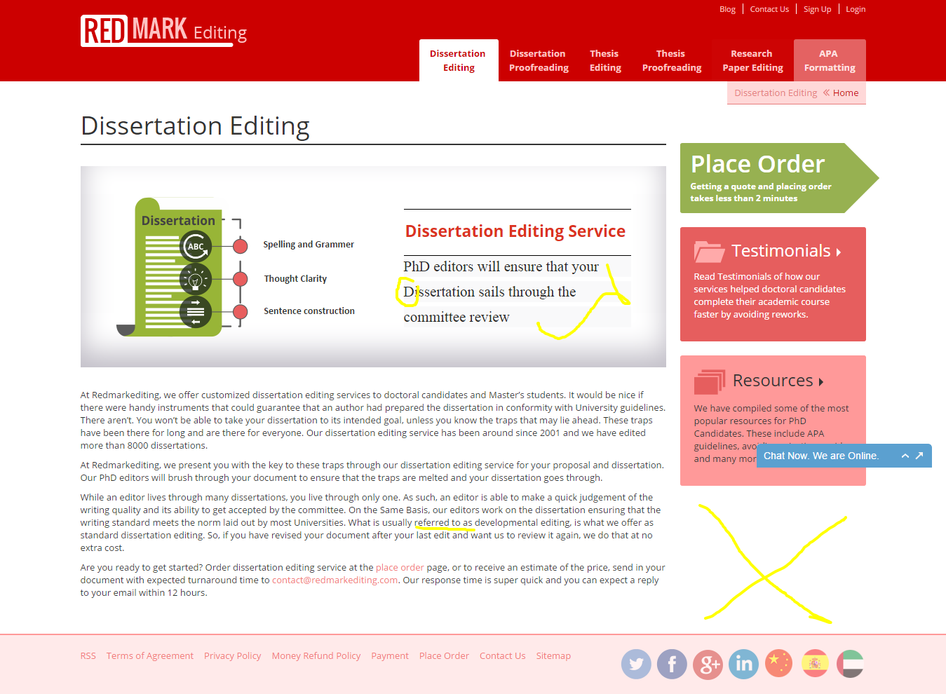

* Dissertation with capital D is not making sense.
* This could be written in a better alignment.
* This empty space can be filled with latest blog posts, but there should be breathing space on the webpage. So, maybe we can only provide the blog link for the latest post.
* Steps for placing order will follow the content. Once basic information is added by the user, he will be directed to the place order page with the details pre-filled.

Dissertation Proofreading Service (http://www.redmarkediting.com/dissertation_proof.html)

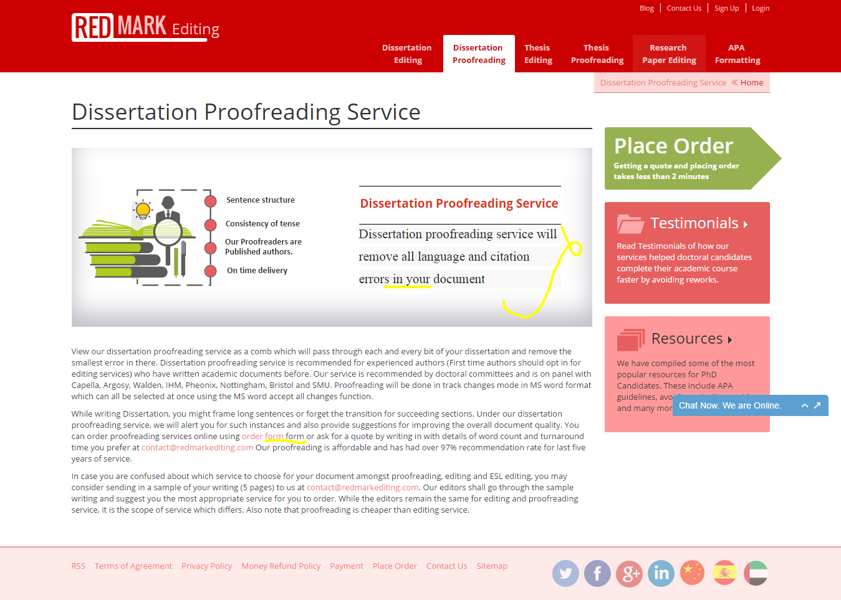

* Highlighted with yellow is content error.
* This could be written in a better alignment.
* Steps for placing order will follow the content. Once basic information is added by the user, he will be directed to the place order page with the details pre-filled.

Thesis Editing service (http://www.redmarkediting.com/thesis_editing.html)

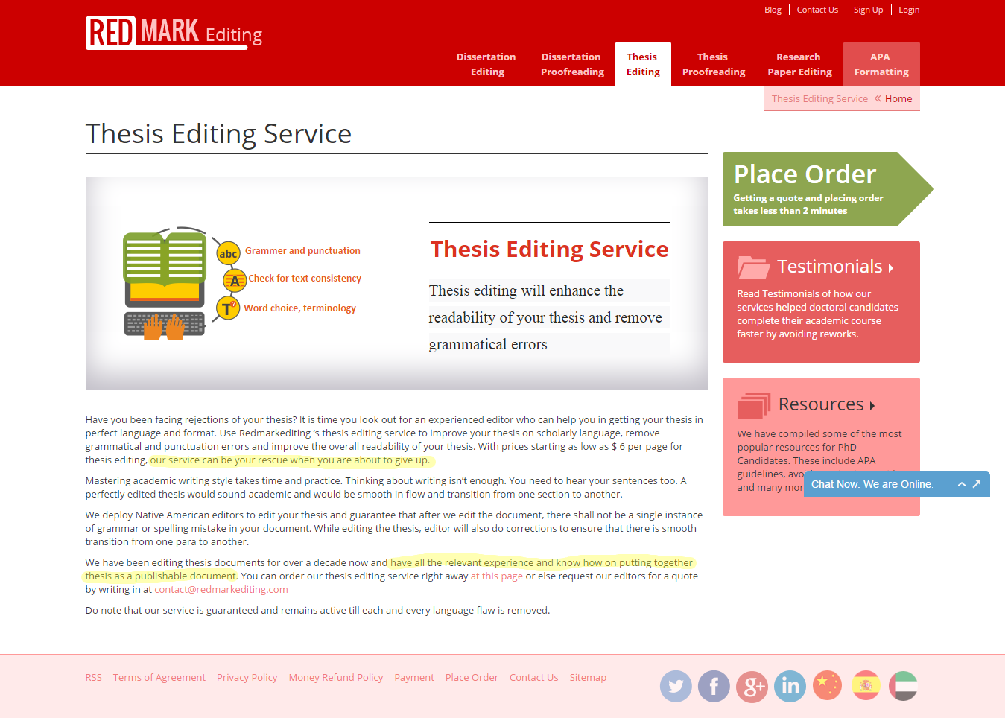

* The highlighted sentences can be reframed.
* This could be written in a better alignment.
* Steps for placing order will follow the content. Once basic information is added by the user, he will be directed to the place order page with the details pre-filled.

Thesis Proofreading Service (http://www.redmarkediting.com/thesis_proof.html)

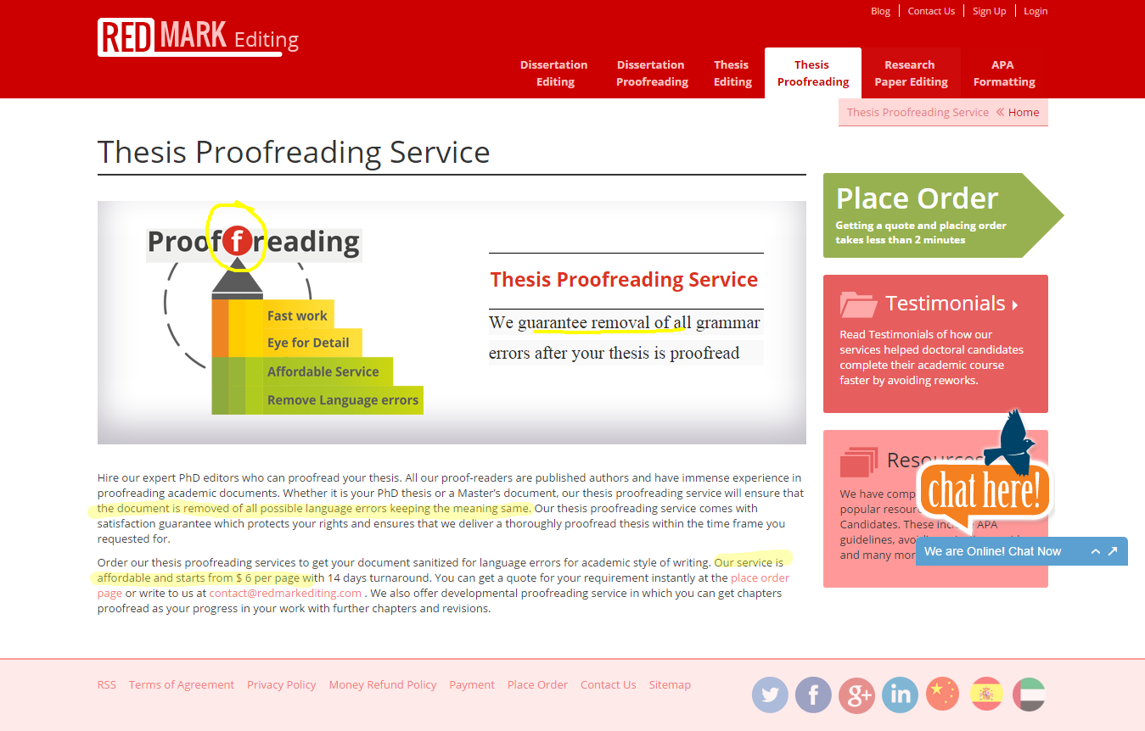

* This sentence is framed properly.
* The highlighted sentences need to be reframed.
* Also we can add more content to this page. So there is room for adding the latest blog post link at the right bottom corner.
* Steps for placing order will follow the content. Once basic information is added by the user, he will be directed to the place order page with the details pre-filled.

Research Paper Editing (http://www.redmarkediting.com/research_paper.html)

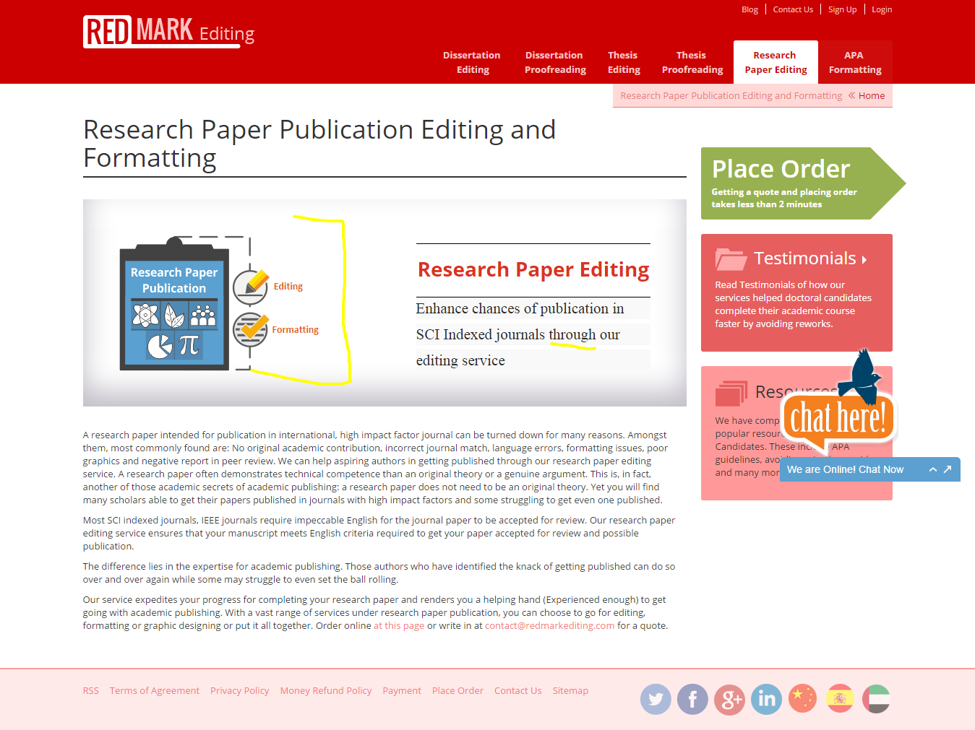

* The size of this image can be increased in order to avoid the white gap.
* The word is not appropriate. It can be replaced with “with”.
* Steps for placing order will follow the content. Once basic information is added by the user, he will be directed to the place order page with the details pre-filled.

**APA Formatting Service** (http://www.redmarkediting.com/APA_formatting.html)

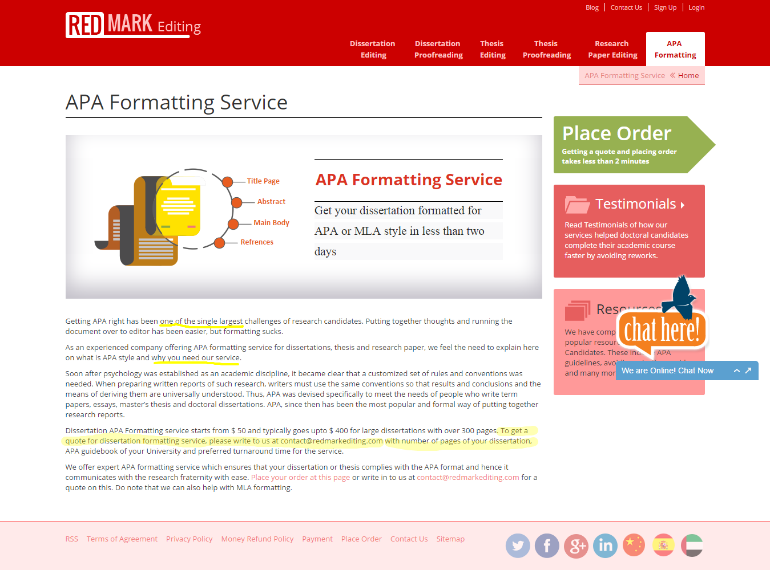

* Sentences need correction.
* The highlighted sentence needs to be reframed.
* Steps for placing order will follow the content. Once basic information is added by the user, he will be directed to the place order page with the details pre-filled.

**Contact Us** (http://www.redmarkediting.com/contact-us.html)

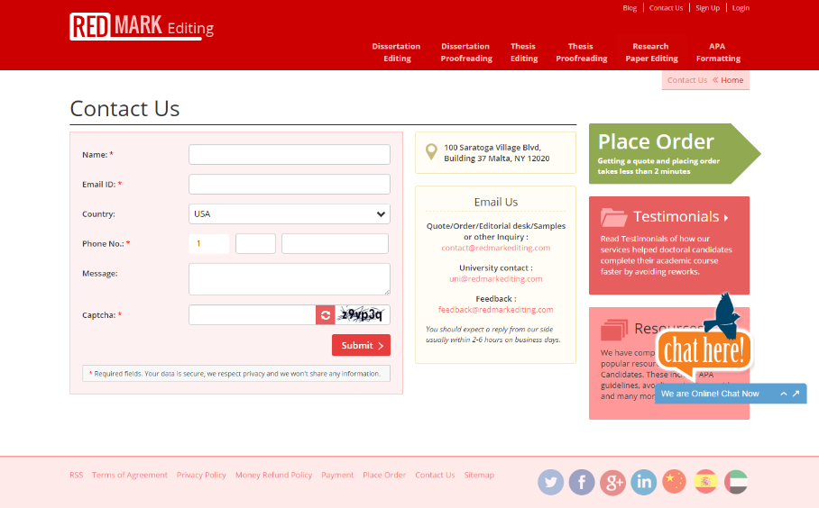

* Contact Number needs to be added to this page

**User Desk**

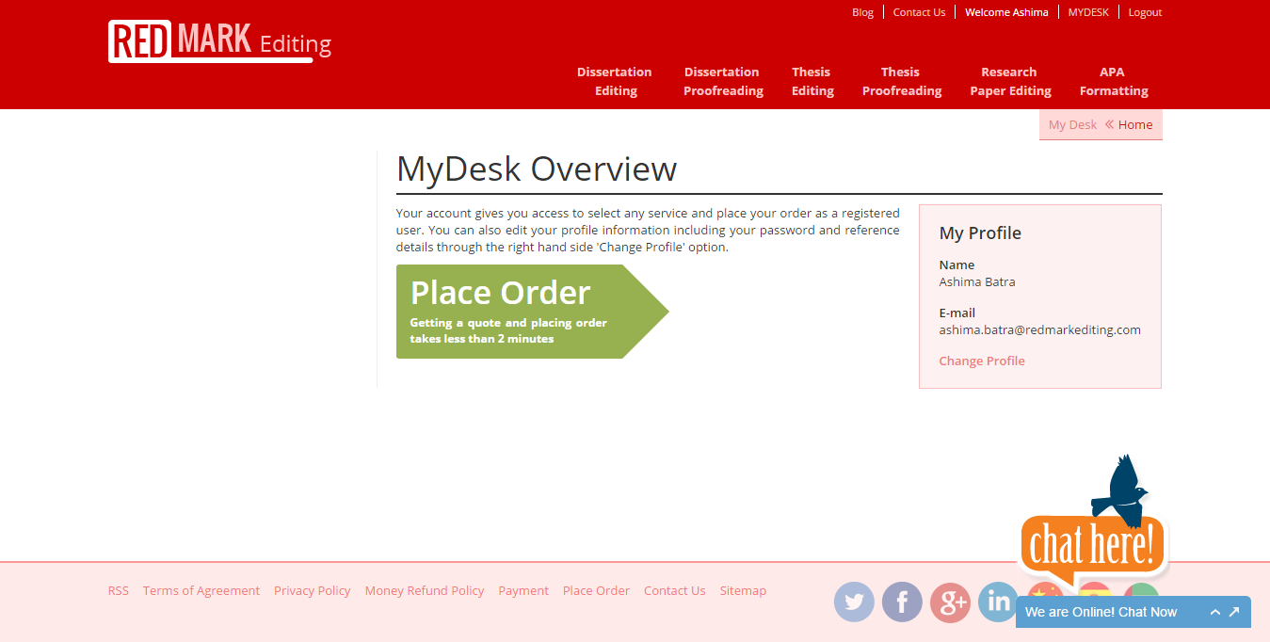

This page needs a makeover as:

* There is too much white space at the screen.
* Everything is aligned to the right side, this needs revision.
* There is no gap between MyDesk Overview and Place order.
* It should be Edit Profile in place of Change Profile.
* This blank space should be filled with testimonials.

User Profile

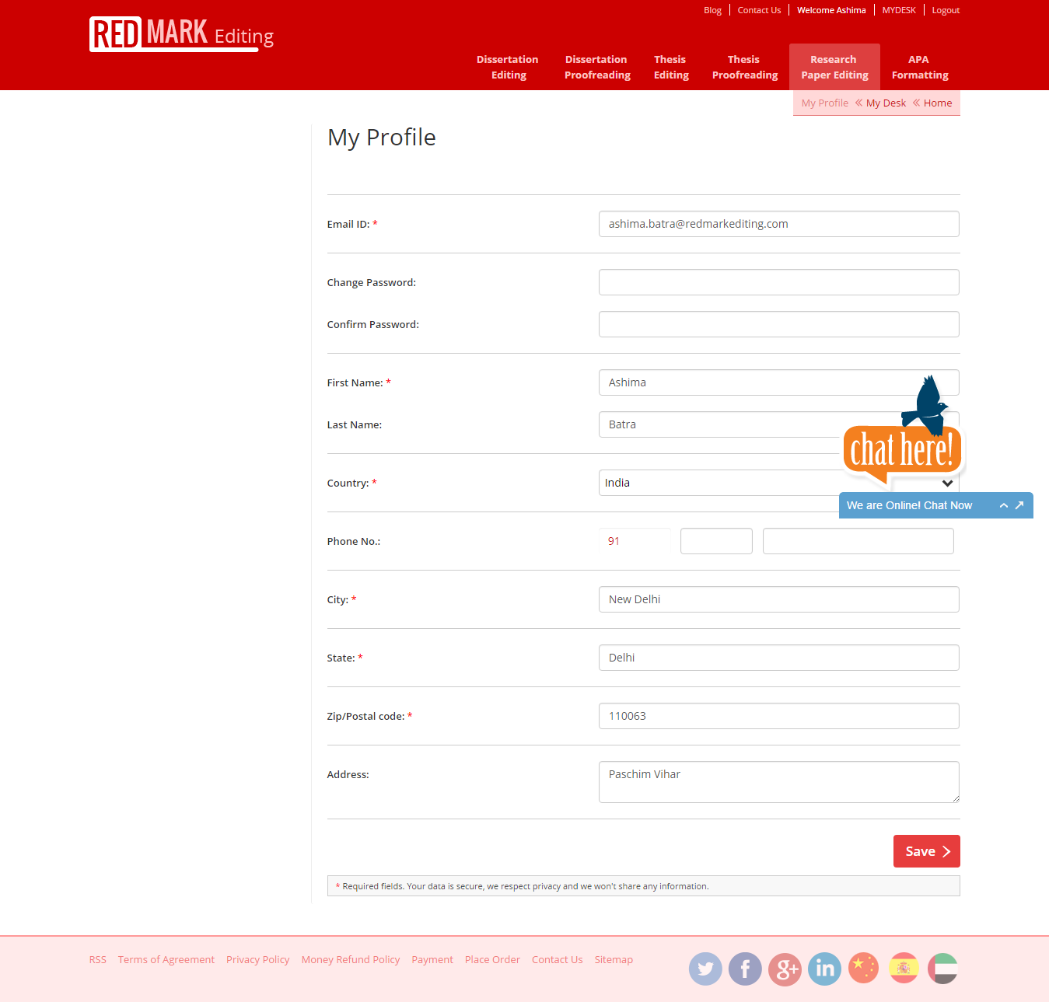

* Too much White space on the web page, this will be filled with testimonials.
* The background color of this page needs to be changed, it make it look better.

Get quote and order online

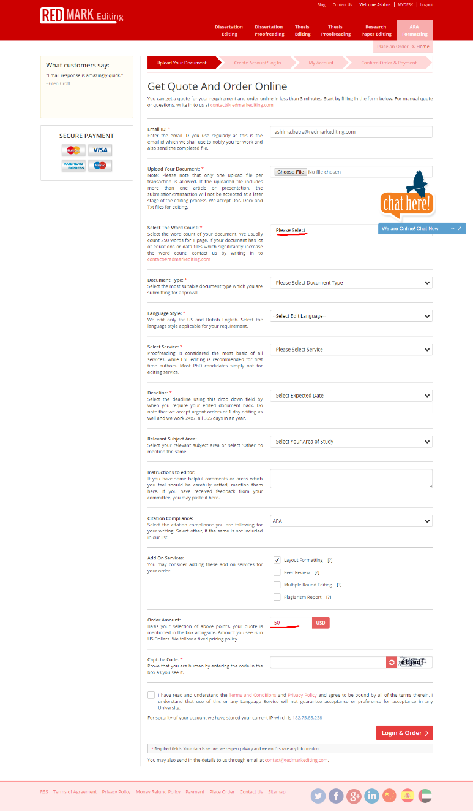

* The amount for any service should not be displayed, unless the number of word count, document type, subject area, services required are not selected by the user.
* Alignment of the page also needs improvement.
* This blank space will be replaced with FAQ’s related to order. Also, any background color (going with the theme of the page) can be added to make it look better.
* What customer says should be made more real. (Top left)
* Secure payment must be removed from here.

Placing an order

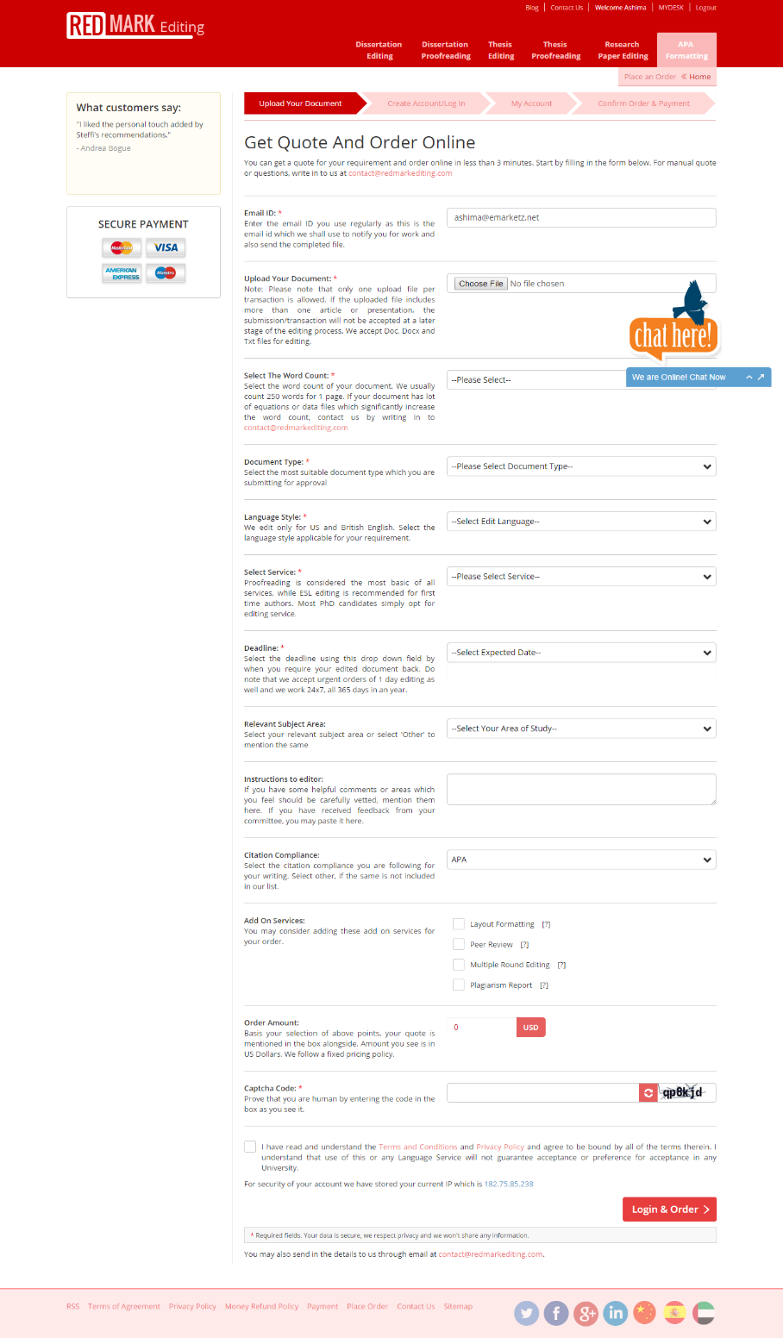

* The structure of this form requires revision.
* Uploading the document should come at the bottom. (With a statement declaring that the document will remain safe with us).
* This should be written as create my account and proceed to order.
* Instruction box size must be increased, with a text start typing here (which will vanish as soon as a user starts writing)
* The sequence for the fields of this page should be in the below mentioned form: (new fields are also added)

1. Name
2. Contact Number
3. E-mail Id
4. Deadline
5. Document length
6. Document type
7. Language style
8. Service required
9. Add on services
10. Subject Area
11. Instructions for editor
12. **Citation Compliance**
13. **Upload document**
14. **Amount to be paid**
15. **Captcha Code**
16. **Terms & conditions**

**While placing the order, I found there is something wrong with the quote given.**

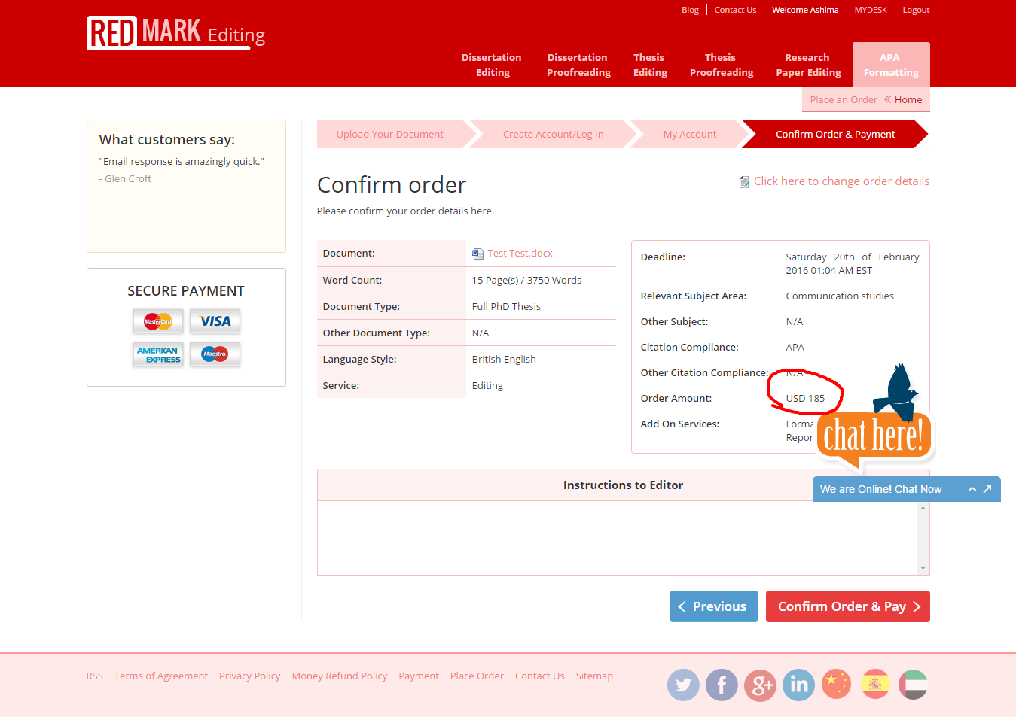

Amount here is USD 185. But when I click here: the amount is changed and I go back to the first page of the process i.e upload your document.

The amount should be reflected as $185

This should also be in a table form same as the left box.

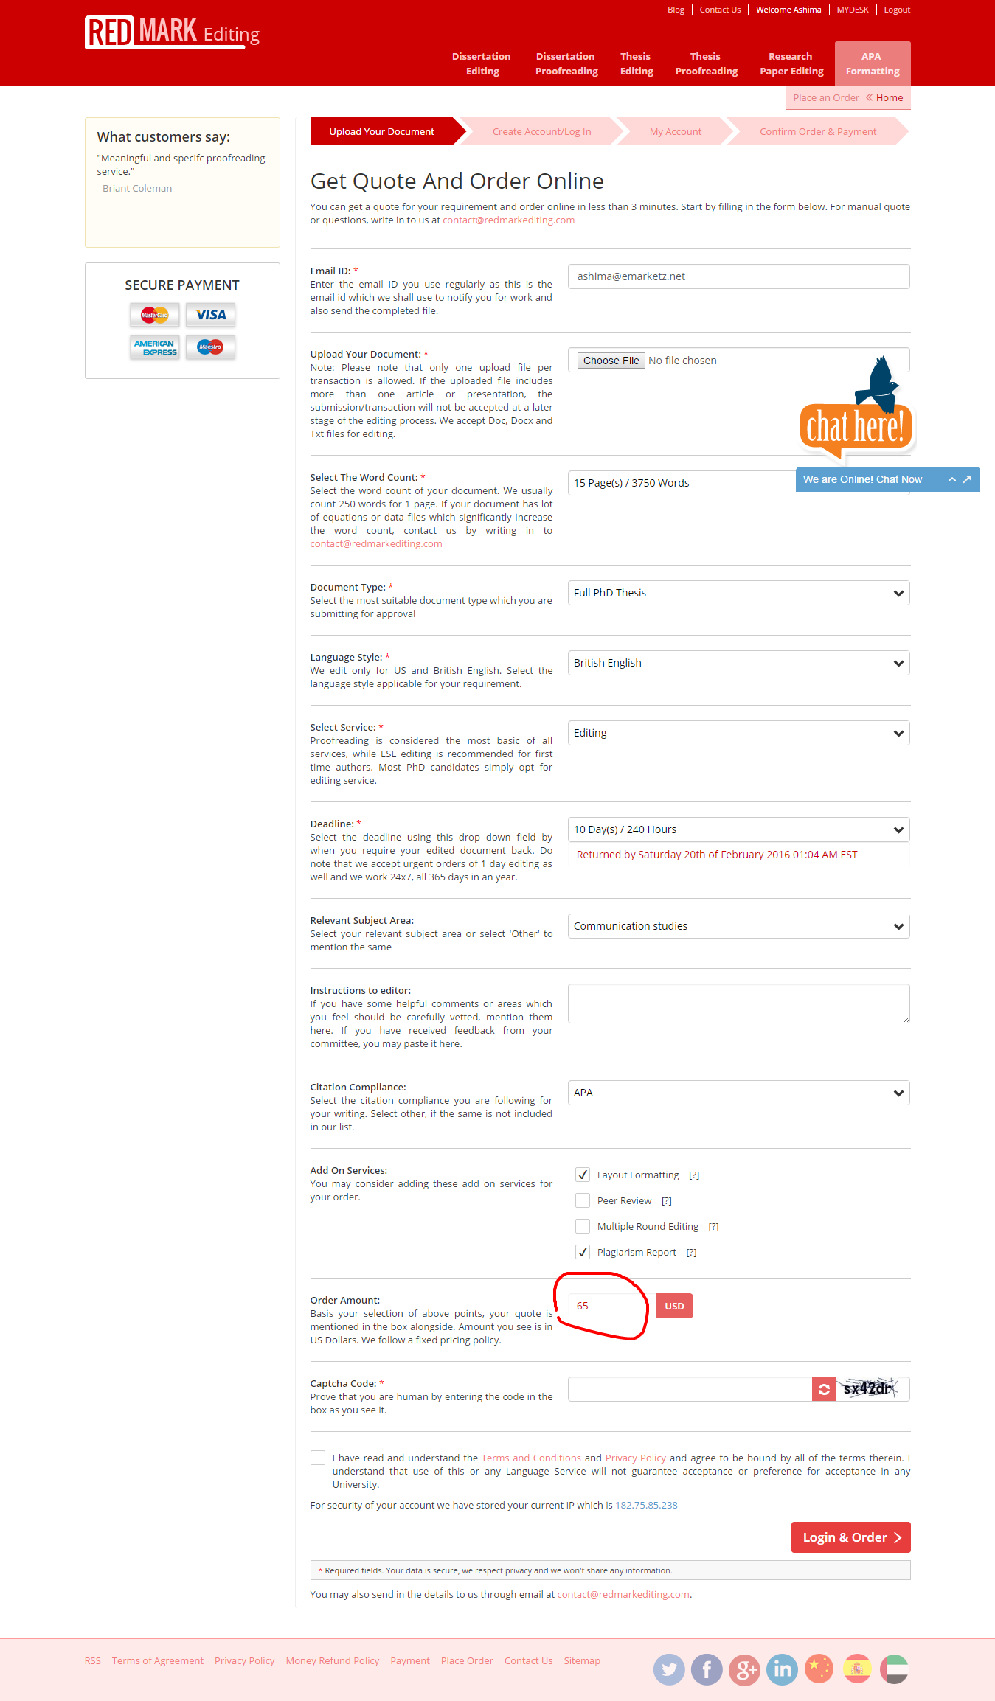

The amount now changes to 65 USD, while the services remain same.